PRIONS

The human prion protein gene and its gene product

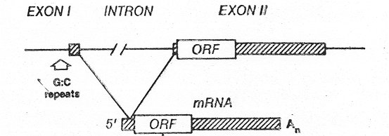

protein synthesis
(253 aa)

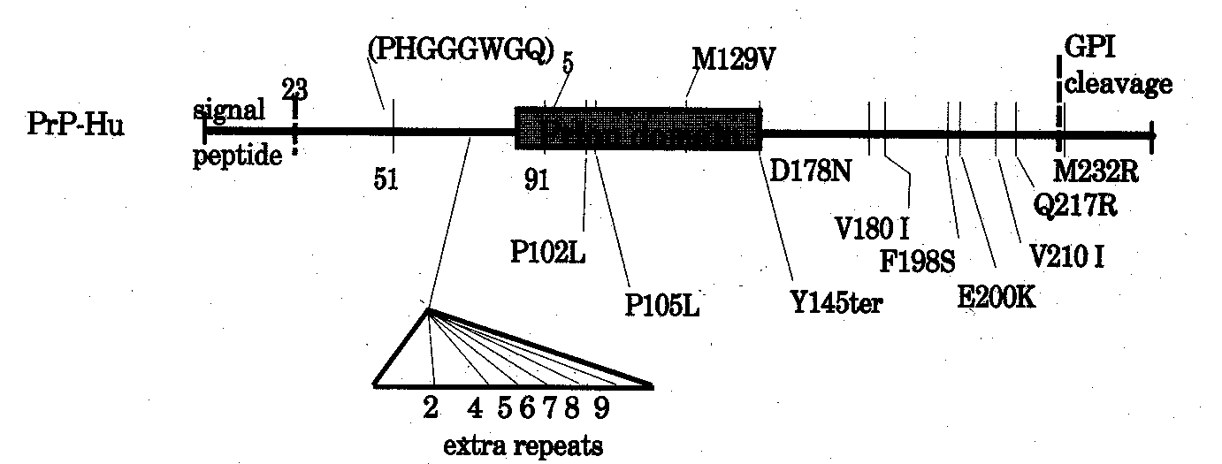

I. The Prion Gene - Prnp
A. Located at 20pter-p12 - human
B. All known mammalian Prnp's have a single ORF
1. exon(s)1 (and 2) contain 5'-UTR
2. exon 2 (or 3) contains ORF & 3'-UTR
3. The ORF is 759 bp
4. Long 3'-UTR
C. intron - 15 kb (with many SINEs, LINEs and
retroposons)
- No TATAAT box - a GC rich region
- See: Genbank AN U29185 (gene) and M13667 (mRNA)
- See also: Prusiner, SB. The Prion Diseases. Sci. Am., Jan., 1995.

II. The Prion Protein
A. The normal protein - Prp^{C}
1. Membrane-bound neuronal protein
2. Function unknown - Cu-binding protein ??
3. Made as a 253 aa peptide - several
post-translational modifications:
a. Signal sequence is recognized & removed
first 23 aa
b. Peptide is removed from c-terminus as GPI is added - last 21 aa
c. Glycans added to two asn: N181 & N197
d. One disulfide bond formed cys₁₇₉-cys₂₁₄
4. Octarepeat: PHGGGWGQ - five times: 51-91
5. The Prion Domain: 85-150 ??
a. Highly conserved among all mammals
b. Probably responsible for conformational
change to PrP^{sc}.
6. Polymorphisms:
a. Less one repeat: -8aa @ repeat site
b. M129V
B. The Altered Prion Protein - PrP^{sc}
1. fCJD - 10% of all cases
a. Extra repeats - esp. 48 aa insertion -
Many families
b. E200K - Lybian Jews, others
c. D178N - (with V at 129) - Many families
d. V210I - classic fCJD
e. Others: Y145ter, F198S, etc.
2. GSS - Most cases are inherited
a. P102L - Many cases
b. A117V - A dementing form of GSS
c. L105P
3. FFI - Inherited, with sleep disorder - has
thalamic involvement
a. D178N - (with M at 129)
b. Others ?
4. Alpers Syndrome - Childhood prion disease ???

