Topic #8: Bryophyte Grade (Unisporangiates), Represented by Mosses

REQUIREMENTS: Powerpoint Presentations.

Objectives

1. List the characteristics that green algae have in common with plants.
2. It takes sophistication to appreciate that a strength of classifying organisms is the recognition that boundaries between groups are, paradoxically, nebulous. Write a brief essay that concludes that the failure of diverse organisms to fit neatly into our somewhat arbitrary schemes is the expected result of evolution.
3. What is the most general characteristic that can be used to distinguish green algae from plants? (Hint: Exceptions occur among the stoneworts (an advanced group of green algae that includes Chara).)
4. In very general terms, compare the following characteristics of green algae and bryophytes: habitat, food conduction, water conduction, anchorage, morphology, life history, gametangia (for this last, see question 3!).
5. Draw the life cycle of a typical moss. Is the protonema filamentous? Does it remind you of a green alga? What is the ploidy level of the protonema? Show the physical relationship of the sporophyte to the gametophyte.
6. Do mosses have true leaves? (Hint: Look up the definition of leaf.)
7. Explain what is meant by "The moss gametophyte has two distinct phases of growth."

Lecture

Phylogenetic Orientation
The first group covered in this course is one of the major groups of organisms on earth today—the angiosperms. As you recall, angiosperms show obvious alternation of generations, and the sporophyte is, by far, the dominant generation. The female gametophyte is buried within the sporophyte (and depends on it for nutrition). The angiosperms have very advanced tissues for translocation of nutrients, water, and reduced substances, such as carbon, nitrogen, and sulfur. The angiosperms have chl a + b + . . . and extract e⁻ from water, producing O₂ as a byproduct. The angiosperms have cell walls containing cellulose. They are distinguished from all other organisms by production of flowers, which in turn produce seeds contained within “vessels.” The gymnosperms, which we will cover last, produce seeds, but these seeds are “naked” (the Greek root “gymno” means "naked").
The survey included the simplest organisms, the prokaryotes. Two groups were considered: the Eubacteria and the Archaea. Investigations using “global” systematic tools (lipid constituents, rRNA sequencing, cell-wall composition) indicate that these two groups diverged quite early in their evolution. Some organisms apparently arose through reduction (e.g., viruses and Rickettsias). It was noted that one group of bacteria, the cyanobacteria, contains chl a. The algae are an informal grouping of organisms that contain chl a and lack complex sexual structures. We focused on the green algae, which have chl a + b + . . . ; whose cell walls are often cellulosic; whose flagella, if present, are usually two in number; and whose carbohydrate food reserve is starch, which is stored in the chloroplast. We used the green algae and plants to demonstrate various evolutionary trends. Clearly, the green algae and plants have a common ancestor.
The task now is to examine plants with more primitive characteristics. It is important to note that the organisms in this and the next topic do not form an evolutionary series leading to gymnosperms thence angiosperms. Given time constraints, I have elected to discuss extant plants with primitive characteristics, instead of fossil plants with primitive characteristics and which are ancestral. (The focus on characteristics and the present trumps lineage.) More specifically, we will deal first with a “side branch,” the bryophyte grade (perhaps better called the unisporangiates because this collection of organisms is unique in having an unbranched sporophyte with a single sporangium). Bryophytes and the Chlorophyta are evolutionarily close. In this course, where our goal is to give you an appreciation of the diversity of life, we will use “bryophytes” in the informal common usage (i.e., to include all the simple plants in which the gametophytic generation is the dominant one and the sporophyte bears a single sporangium). In this usage, bryophytes include real mosses, liverworts, and hornworts. Formally, the division Bryophyta includes only mosses, and were this an advanced plant taxonomy course, we would restrict the meaning thus (but, of course, early on in the course, we noted that exact names change). We will cover only one group of bryophytes in detail, the “true” mosses (one of three kinds of organisms that are botanically classified as real mosses). Focus on mosses!

POWERPOINT SLIDE: Scope of coverage in BOT 3015

POWERPOINT SLIDE: Evolutionary relationship of plants and green alga, with focus on bryophytes

Attributes of Bryophytes

POWERPOINT SLIDE: A comparison of bryophytes and algae.

POWERPOINT SLIDE: A comparison of bryophytes and other plants.

POWERPOINT SLIDE: Moss gametophyte (north Leon County).

Characteristic | Algae | Bryophytes
Habitat | mostly aquatic or marine | mostly terrestrial
Food conduction | specialized cells generally absent; a few have sieve-like cells (browns) | mostly conduction through relatively unspecialized cells
Water conduction | specialized cells absent | simple cells may be present
Anchorage | specialized region generally absent (but recall Fucus morphology) | rhizoids for anchorage and nutrient absorption often present
Morphology | generally unicellular or filamentous; a few with parenchymatous or coenocytic morphology | generally parenchymatous
Life history | alternation of generations in some forms—sporophytes and gametophytes independent | alternation of generations in all forms—sporophyte dependent on gametophyte at least for a period
Gametangia | single cells or groups of single cells not accompanied by a jacket of sterile cells | complex reproductive structures
Characteristic | Bryophytes | Other plants
Sporophyte dominance | no | yes
Sporophyte dependence | “yes” | “no”
Vascular tissue | absent, simple | complex
Sporangia/sporophyte | one | many
Lignin (support compound) | “no” (“protolignin”) | yes
Size | small | may be large
True roots, leaves | no | yes (most groups)
Water, mineral absorption | general | mostly through roots
Protective layers (cuticle) | poorly developed | exquisitely developed
Sporophyte | annual, ephemeral, unbranched | often perennial, many branches
Gametophyte | free-living | free-living (“all” seedless plants)  —OR—  enclosed in sporophyte (female of all seed plants)

Bryophytes are distinguished from other plants by their general lack of specialized conducting cells—they are the nonvascular plants. This generality has exceptions, but clearly bryophytes do not have conducting cells specialized to the extent that other plants do: (A) When present, specialized water-conducting cells of bryophytes (hydroids) lack the irregular wall thickening of tracheary elements. (B) When present, specialized food-conducting cells (leptoids) are rudimentary (each has a nucleus, and they lack sieve plates). A key element apparently lacking in the simplified vascular tissue of mosses is lignin. Although bryophytes are “nonvascular” plants, it is important to keep in mind that this is a relative statement. In fact, the “lack” of vascular tissue in bryophytes probably results from a loss of this feature, not a failure to acquire it.
Bryophytes and other plants have a common ancestor, but neither is ancestral to the other.
Bryophytes have a multicellular sporophyte generation that, for at least some time, is dependent upon the gametophyte for nutrition produced by photosynthesis. The sporophyte is epiphytic, a primitive condition. Bryophytes, like all other plants and green algae contain chl a + b + . . . . Observe

the biflagellate sperm and egg (bryophytes are oogamous). A liquid water phase is required for fertilization. (The sperm swim from the antheridium to the archegonium.)

Specific Attributes of Mosses (Muscopsida)

Mosses are the most recently evolved group of the bryophytes. Hallmarks of this group of organisms are:
(A) The gametophyte generation always has two distinct phases of growth (most other nonvascular plants typically have but one phase).
(B) The second phase of the gametophyte is always upright, “leafy,” and radially symmetrical.
(C) The mosses have complex multicellular rhizoids (root-like structures).
(D) Stomata are present on moss sporophytes; stomata are unusual among nonvascular plants.

POWERPOINT SLIDE: Moss gametophyte (north Leon County, Florida) showing epiphytic nature of sporophyte (north Leon County, Florida).

POWERPOINT SLIDE: Typical moss life history (custom).

(A) (at 8 o'clock) Haploid spores germinate, giving rise to the first phase of the gametophyte generation, the protonema (“first” + “thread”). This growth phase is filamentous and resembles a green alga.
(B) Buds develop on the protonema. These buds give rise to the second phase of gametophyte growth.
(C) At the apex of the gametophyte, archegonia or antheridia differentiate (on different shoots or entirely different plants).
(D) Sperm released from the antheridium swim (in liquid water) into the neck of the archegonium and fertilize the egg.
Archegonial neck-canal cells (the row of cells up the channel) lyse, forming an open channel down to the egg. The exudate is attractive to sperm. (Otherwise, how would they “know” where to go?). We have ignored these “guidance systems,” although we have encountered them before (e.g., in the hyphal tips growing together in the zygomycetes). Usually these systems are based on special messenger compounds, but in mosses, it appears that sugars and amino acids released from lysed cells are sufficient.
(E) The sporophyte develops and pushes up the archegonium, which is sloughed away.
(F) (at 7 o'clock) As the sporangium develops, meiosis occurs within it, and haploid spores are released

CHART: SOME CHARACTERISTICS OF TWO TAXA OF BRYOPHYTES^{a,b}

Taxon | Example | Body organization | Anchorage | Complexity of sporophyte | Specialized conducting cells | Gas exchange
Hepaticae,  liverworts | Marchantia | thallose or leafy^{d}  (if leafy, not upright) (only some liverworts have protonema) | rhizoids are single-celled | less complex (ejection of spores aided by elaters) | absent | thallose form has multicellular pores, the aperture size of which is not adjusted from moment to moment
Musci,  mosses | Sphagnum | leafy and usually upright gametophyte; gameto-phyte has two distinct phases of growth | rhizoids are multicellular | more complex (specialized and complicated sporan-gium) | simple if present | single-cell stomata on sporophyte

ªIn the kingdom Plantae, we have so far distinguished vascular and nonvascular plants. Bryophytes are the so-called nonvascular plants. “All” plants are autotrophic multicellular organisms that show a high degree of tissue differentiation. All plants produce gametes by mitosis (i.e., they have a gametophyte generation). All plants have a diploid stage that includes an embryo (from roots meaning “in” + “swell”). (In all plants, the diploid zygote is retained within the female gametangium and develops into the embryo; in contrast, in green algae, the development of the zygote is essentially independent of the gametophyte.)
^{b}Bryophytes can be distinguished from vascular plants on the following bases: (1) Bryophytes have no or only a simplified conducting system. Because leaf, stem, and root are defined by vascular systems, strictly speaking, bryophytes lack these structures. (2) Bryophytes have no apparent cuticle. (3) When stomata are present, each consists of but a single donut-shaped guard cell. (4) In bryophytes, the gametophyte generation is the predominant one, upon which the sporophyte is nutritionally dependent at least for a time. In vascular plants, the sporophyte is the conspicuous generation.
^{c}We say “leafy” only for convenience. The “leaves” are only one cell layer thick and lack vascular tissue.

This table is a supplement that is thought to be useful for students in BOT 3015 although liverworts (another kind of bryophyte) are not covered in this course.
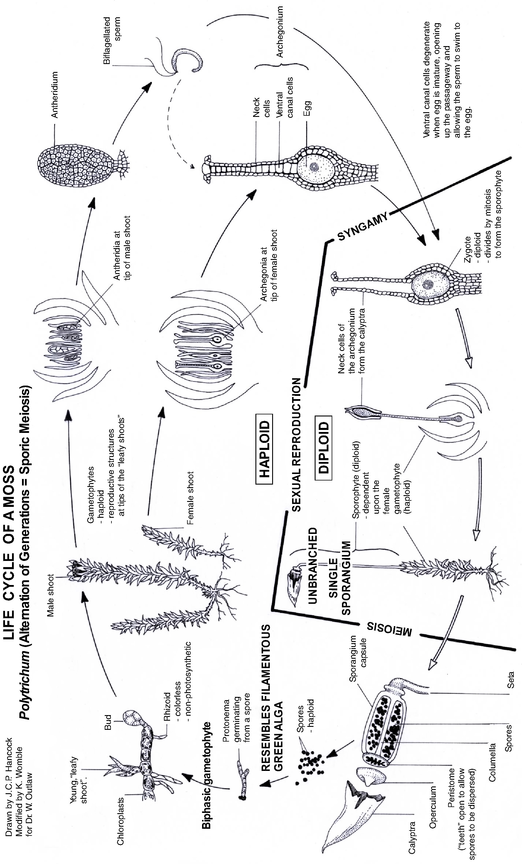

“Bryo” means moss. Interestingly, in early classifications schemes, seedless plants (like mosses and ferns) were classified, along with fungi (!), as Cryptogams, which means “hidden/enigmatic marriage.”

