Chapter 1

Orientation to Plant-Biology Lab
Why study plants? An introduction to plants
Plants sustain life on earth by trapping light energy and converting it into stable chemical energy. Photosynthetic organisms appeared about 3.5 billion years ago (the first human-like primates appeared a mere 2 million years ago). Plants have evolved into biochemically complex organisms that dominate the landscape.
Human civilization has long depended on plant life for sustenance. We have exploited plant resources in several ways, primarily for food and fiber through agriculture and for energy through fossil deposits. In order to utilize plant resources, we must gain a better understanding of how plants work. This understanding began at the dawn of civilization, and today we are in the midst of an exciting era in plant biology.
Scientists in fields ranging from taxonomy to biochemistry and molecular biology are elucidating the diversity and complexity of plant life. In the last several decades, we have gained a significant understanding of various plant processes. Our basic understanding has served as the key step into the new era in plant biology, in which we can design plants that use natural resources efficiently, are resistant to various pests, and are more productive. These products of plant biotechnology (which is itself a product of the basic plant sciences) promise to be the tools that would help us effectively manage our critical resources (land and water), while still fulfilling the needs of the growing human population.
This lab course is designed to introduce the student to the variety and complexity of plant life, and to plant interactions with other living organisms. We will take an observational as well as an experimental approach to understand plants. First, we will study seed plants particularly as they relate to mankind. Second, we will study briefly the biology of non-seed plants, such as ferns. Third, we will explore organisms that were traditionally considered plants, but are now classified into other kingdoms (some protists and fungi). In the course of the semester, we will also conduct experiments to study plant growth and development, and plant interactions with other organisms. These experiments are designed to teach students to think critically, to design and execute experiments to answer specific questions, and to communicate the results effectively.
Doing good science
Good scientists have a common set of qualities that are acquired from experience and practice.
Good observational skills. Good science stems from making keen observations. In many lab exercises, you will be expected to observe several slides and specimens and make drawings. The purpose of creating drawings is to maximize observation. Describing what you observe would require more effort and provide less information than drawing; however, combinations of drawings and descriptions can provide a clear account of what is observed. Hypotheses stem from observations. For example, if you are shown a drawing of a cell without a nucleus, you might hypothesize that a) the cell never had a nucleus b) the nucleus has degenerated c) the nucleus was not visible under the conditions in which the observations were made d) the nucleus is indistinguishable from other organelles e)…Your drawings and observations must be accurate to what is observed to prevent erroneous hypotheses. In the previous example, a description that the drawing is made from a cross section would let us know that we cannot exclude hypothesis c. In addition, observation of surrounding cells that have distinguishable nuclei would, generally, exclude hypotheses a. Good observation skills are required for many aspects of life. A good doctor would not make diagnoses without keen observations and experiments. For example, if a doctor makes observations leading to the conclusion that a patient has diabetes, the doctor would perform an experiment to test glucose metabolism in the patient. In this course, we want you to explore the limits of your observations and then expand them. Carefully observe each slide or specimen. Note the orientation and proportions of various structures, especially on slides. Make neat (not necessarily artistic) and scientifically correct drawings in pencil. Drawings must be of precisely what is seen, not what is supposedly seen. Instructors will check during the exercise and compare drawings with what is under the microscope. Analyze parts in relation to their names; this analysis will help you remember them better. Keep your eyes open and your curiosity alive. Note anything unusual that you may observe, even if you are not asked to label it.
Good record-keeping skills (maintaining a lab notebook). Though underappreciated by novices, good record-keeping is imperative to doing good science. In this course, the importance of the notebook is emphasized. Thus, each student will maintain a notebook, and record his/her observations (notes/drawings) during each lab period. Utilize the spaces in the lab manual for your observations and drawings, if needed, left-hand pages may be used for calculations, graphical presentation of data recorded on nearby right-hand pages, and for additional drawings or observations for which inadequate space was provided on the right-hand pages. All drawings and observations of specimens in class must be completed in class and according to what is actually seen. If any work is edited, you must indicate so by writing the date and what was edited. For example, if you are studying and find that you have mislabeled, you may correct the mistake, then you must write something like “corrected label from “stigma” to “style” on April 10, 2007” under the drawing.
- Observations.. While examining specimens/slides, observations must be recorded during lab. Drawings should be in pencil on unlined, right-hand pages of your notebook and each about ½ the size of the paper. Include a clear description of what is drawn, including such things as scientific and/or common name of specimen, what type of section it is (e.g. cross section, longitudinal section, whole mount, etc.), magnification (total (eyepiece x objective)), what type of tissue (e.g. leaf, root tip, etc.), objective of looking at the specimen (e.g. visualize mitosis, vascular system, comparing dicot and monocot root, etc.). Always include any procedure that was followed to obtain or visualize the sample. All drawings should be drawn as seen in the microscope. Use close and accurate observation. Label drawings with arrow-free pointers and write in normal orientation (horizontal plane and right side up). Notice shape, size, contents, patterns, and movement. Parts of the specimen should be drawn to scale and a scale bar should be included when possible. An example of a good drawing can be found at http://www.zoology.ubc.ca/courses/bio332/Images/amoeba1.jpg. Note that although the details are not drawn throughout the whole specimen, there is detail as seen in the microscope and notes describe where and what detail is not drawn. All of the parts are drawn, although repetitive parts do not need to be drawn. Now compare to http://www.zoology.ubc.ca/courses/bio332/Images/amoeba2.jpg.
- Experiments. Experimental procedures should be entered into your lab notebook before the experiment is performed. Any changes to the planned experiment must be indicated by marking a single line through that portion and correcting directly below the plan.
The system to ensure that protocols are followed in this course is to place a check by each task as it is accomplished. A statement such as “experiment like pg 10” is inadequate. A typical protocol can be recorded as shown on the following:
******************************
13 June 2005

Treatment of Brassica rapa plants with GA

Time: 10:05 am

_√__ Measure plant heights

1. _20_ mm
2. _40_ mm

_√_ Apply 20 µl 100 µM GA to 1st leaf of plants 1, 2 and 3.

___ Apply 20 µl 10 µM GA to 1st leaf of plants 4, 5 and 6.

____ ……..etc.…….
******************************

Even now, your experiment is not over. Analyze your data. Discuss your interpretation with the TA. Write out your protocol for the next experiment.
Good problem-solving skills. Good science is all about solving problems. This skill is especially important when you design experiments. First, identify the question(s) you seek to answer. Second, design an experiment or experiments that will test your ideas. Include required controls in your experiment. Finally, if the results are inconclusive, devise a new plan. Your problem-solving skills are assessed through experimentation; thus, your best effort is rewarded.
Good organizational skills. There is no substitute for being neat and organized in experimentation and analysis. Have your tools and materials ready before you start an experiment, so that you do not flounder during an important step. Outline procedures before you start, and check each off as you follow them.
While analyzing data, list additional questions that you could answer from the experiments that you conducted. Organize your data, and select the most appropriate representation of the data (A table? A line graph? A bar graph? What should the axes on your graphs represent? &c.).
Good writing and communication skills (writing a scientific report). This essential skill is learned by practice. A scientist must effectively communicate his results and their implications in a clear, precise, and scientific manner. A substantial cost is associated with creating new knowledge that merits publication in a journal. In brief, present your work carefully if you expect it to be read. Only work distilled to essentials can be published. (In other words, a scientific report is not a diary.) Understanding the importance and costs of communicating science puts one well on his way to creating a good report. Of course, the best way to learn to write is to read, and then write for the purpose at hand. In summary, make your point in the most straightforward manner. There is no room for personal style, rambling, or inaccuracies in scientific writing.

Organization of a lab report.
Importantly, avoid plagiarism. The best way to avoid plagiarism is to read materials to learn, synthesize the ideas into your own thoughts and words, write your own sentences, and then cite the work that initiated the process. Although, appropriate in some cases, quoting other writers is not acceptable in this course. If you feel that quoting another writer is necessary to make your point, consult with the instructor before submitting work. Copying any portion of the work of others is plagiarism, with or without citation. This includes slight modifications. Remember to synthesize your own thoughts and sentences and if reading the work of others was part of your synthesis, cite. Although work is done in groups and discussions take place between groups of people, all writing and data analysis and presentation must be done independently. Finally, if you have questions regarding how to avoid plagiarism, see your instructor before submitting the work for credit.
Be sure the sections of your work are clearly marked. The best way to do this is to model your paper after a primary scientific article. For examples see journals such as Plant Physiology, Plant Cell, Proceedings of the National Academy of Sciences, Science, and Nature.
  - Title. Thousands and thousands of people will read your title. How many will be stimulated to read your paper? Make every word count. Here’s a bad title: "Effect of temperature on plants." Here is a good title: "The temperature threshold for dormancy induction in Malus seedlings." Remember that generally articles are not even retrieved by people; computers do it on the basis of key words, words in the title, author, or citations. "Effects of..." or "Studies on..." are meaningless expressions. On the other hand, "dormancy" will alert the searcher right away. No one will retrieve the first title because there is little chance that the study will be relevant to the researcher.
  - Introduction. The purpose of the introduction is to state the nature and the scope of the problem. Clearly state the question your experiment addresses, the goal of the experiment, the hypotheses you made, and the rationale behind that hypotheses. The hypothesis is one of the most critical elements of scientific inquiry. Formulation of a hypothesis requires a comprehensive knowledge of the area of inquiry, the ability to distinguish important from unimportant questions, and the conceptual skills to devise a question that can be tested with proposed approaches and which yield an unambiguous answer. The hypothesis and goal(s) obviously overlap. Demonstrate your rationale for the hypothesis. The introduction shouls answer questions such as, why was it interesting and worthwhile to do? How will your experiments further our understanding of the system you are investigating? What is known about the plants, cells, chemicals, systems, conditions, etc. that are involved in your experiment? You should provide scientific background; the reader in your target audience should not have to consult other work for a general understanding of your paper. What will the data permit the reader to conclude and understand better? Chart the course that will follow; the introduction is a kind of map.. An introduction is generally 500-1000 words and is created by reading several sources of information and then relating what you have read to the experiment that you have done. Remember that paraphrasing, pasting together portions of sentences written by others, and copying work of others are all forms of plagiarism and will not be accepted. You must synthesize the introduction from your own ideas and words and then cite the sources of information that initiated your thought process.
  - Materials and methods (written in past tense and paragraph format). Full details that permit a competent colleague to reproduce your work are required. Include important details such as plant used, materials used, description of experimental set-up, methods in detail (details of what you did and when, what special care you took in what step, etc.), and details of the experimental conditions (e.g. time of day and temperature) when they are important to the interpretation of the data.
The Materials and methods, and the Results are the cornerstones of a scientific paper. It is fine to reference other work that is readily available or common knowledge. Everyone will know "according to the method of Lowry et al. (1951)," but for most methods, even if you reference, you will want to give the reader a notion of the approach, e.g., "Potassium was determined by flame photometry (Doe and Doe, 2005)." Note the method of inserting a citation within the text.
  - Results. This is the new knowledge, your contribution. It is not a place to rehash methods. It is not a place to express opinions. Predigest your data. Do not present the raw data, but rather, present the data in a clear way that summarizes or represents the data, e.g. graphs and tables with averages, representations of variation, observations, and statistical analyses. Remember that the other parts of the report are included as support for the results. Use a written section to describe the results of the experiment and to support and refer to any graphical representations. For figures and tables, include a written legend below each graph and table that describes what is being represented. Again, model after papers published in scientific journals
  - Discussion. The discussion is perhaps the hardest part to write, as it requires “the grand vision.” What do the data mean? How do your results and all other results provide a more complete interpretation of how the world works? Your task here is to discuss, not simply to restate, the results. Do your data fit with those of Jones et al. (2004)? Are your results internally inconsistent? Point to the strengths and weaknesses of your work. Are there alternative interpretations?
  - Literature Cited (or References). Research starts with the literature, and it is fitting that the report should end with it. Remember to use in-text citations, e.g. (Doe and Smith, 2005), to show where in the report the information from the reference was referred. Restrict the number of references to the minimum.. For generally accepted ideas (e.g. mass action), use no reference. For accepted ideas more or less peripheral to the central issue of your work, provide a reference to the secondary literature (reviews). Then, the choice is harder. Do not simply cite a paper because it conveniently supports your work. Do what is right, fair, and accurate.
Cite papers in the reference list as follows:
Author. Year. Title. Journal name Journal volume: Page numbers
e.g. Doe JJ, Smith SM 2005 Process methods for large-scale production of plant antibodies. J Expt Bot 5: 25-34.
In summary, your lab reports should be set up like a research article in a scientific journal, so use one as a model. Although journal styles vary somewhat—the Abstract might be called a Summary or the Methods may be placed after the Discussion—all papers have in principle the elements listed above. The quality of your reports and the explanation of results are as important as your results themselves. In other words, despite your best efforts, you may not obtain interpretable results. In this class, a report is required; in the real world, those results are not of interest, but may form the basis for further investigations. Remember, an investigator is not out to prove a point. She or he develops a testable hypothesis, executes a research plan, and decides whether the results support the hypothesis or invalidate it. Remember, we do not prove hypotheses, rather data supports them or invalidates them.
Use of the microscope objectives. Identify the parts of the compound transmitted-light microscope and understand their functions. Know the available magnifications. Define resolution. Understand the difference between magnification and resolution. Compare sizes of various biological structures that are presented throughout the course.
Use and Care of the Light Microscope
The most obvious function of the microscope is to magnify small objects that are otherwise invisible. Various innovations have been made in light microscopy, but generally resolving power is the most useful property. Resolving power permits the user to distinguish two parallel lines. Limited by physics, the best ordinary modern compound microscopes allow distinction of objects that are as close as 0.2 μm (0.2 x 10⁻⁶ m). In other words, if two lines are < 0.2 µm apart, they will appear as one line. Instructional microscopes are not this good, of course, but have a resolution of ~1 μm. Remember, the resolving power—not raw magnification—is the important parameter; magnification without resolution is empty. Given BOT 3015 prerequisites, this section will provide only a brief review and pertain only to ordinary transmitted-light microscopes.
Microscope components. A base supports the microscope and houses the light source (see figure). Light from the source is concentrated on the stage by a condenser lens, and passes through the specimen placed on the stage. Next, the light passes through the objective lens, which is housed on the nosepiece, and provides most of the magnification. Light then passes through the body tube, into the eyepiece lens (or ocular), and eventually forms an image on one’s retina.
Use of the instructional microscope. This refresher section applies specifically to the BOT 3015L microscopes and also provides a baseline for the care of any scientific instrument.
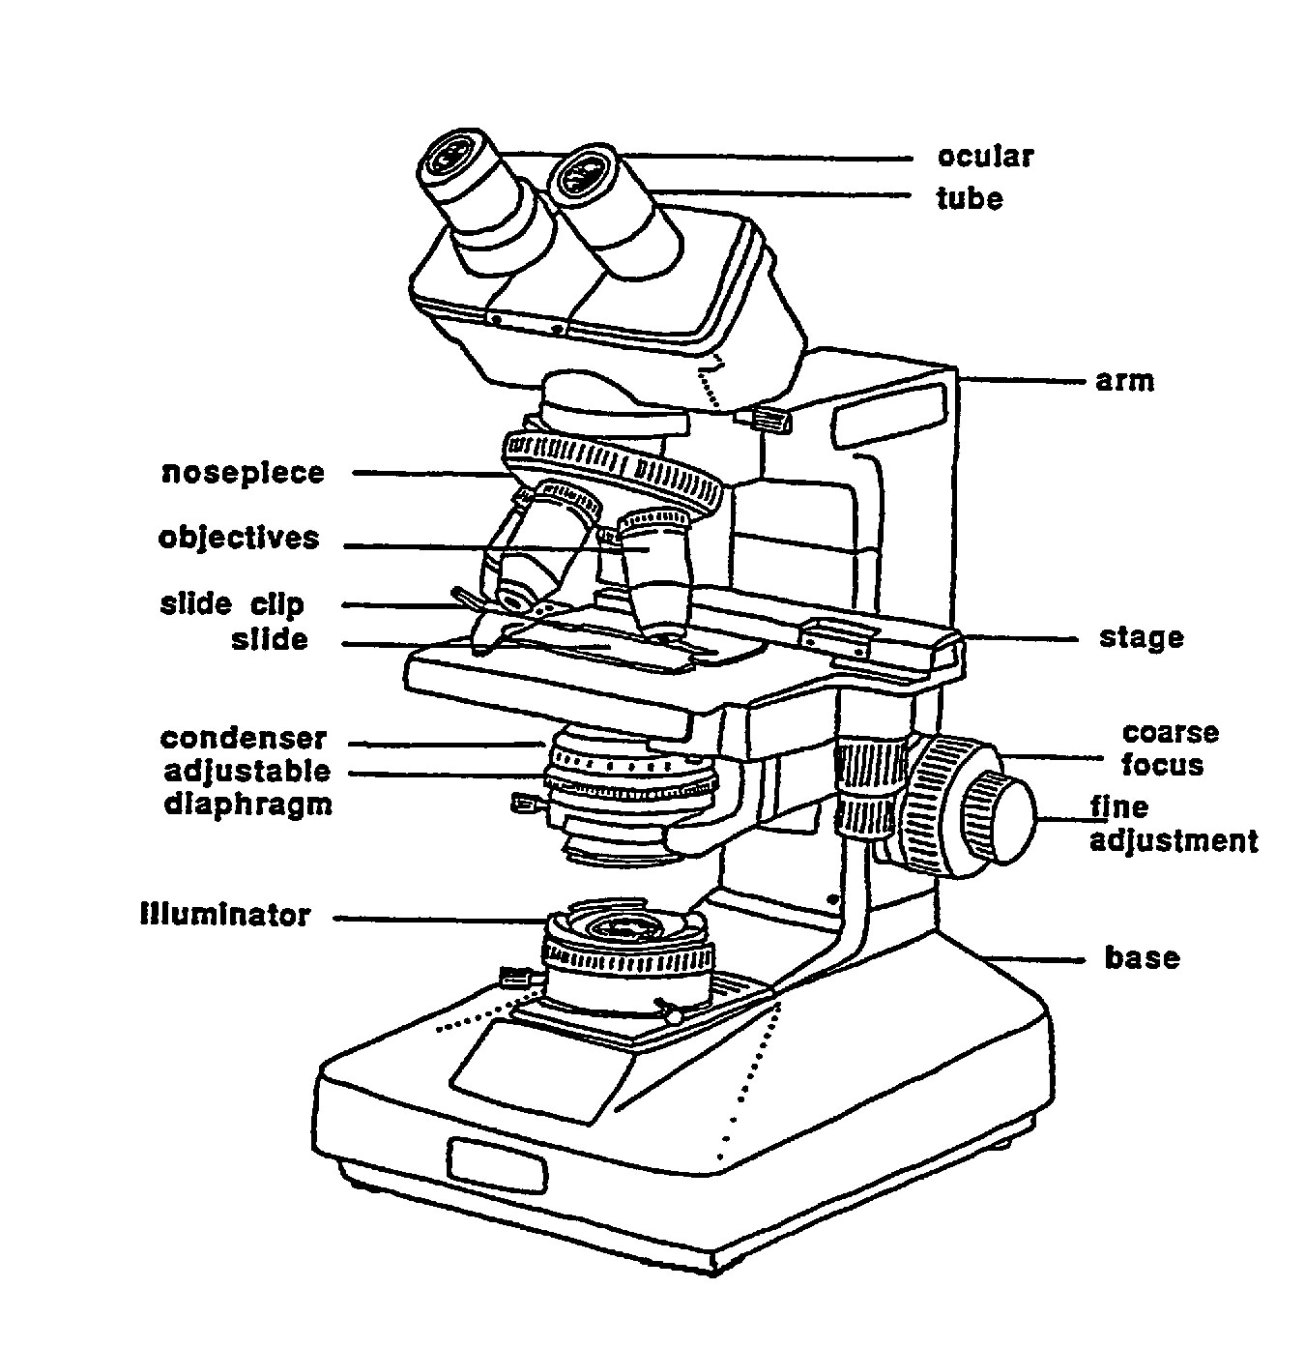
1. Retrieving the microscope. Remove the dust cover (which should always be on the microscope in storage). Grip the microscope with one hand holding the arm and the other, the base.
2. Routine cleaning. Develop a habit of cleaning the lens each time the microscope is used. Only use lens paper. (Other products are not lint-free and may scratch the lens.)
3. Powering the microscope. Plug in the microscope and switch on the light source.
4. Initial Settings. Rotate the nosepiece until the detent for the low-magnification lens (4X) is seated. (The other objectives provide 10X and 40X magnification, respectively.) Place the slide on the stage and secure it using stage clamps. The lens must be a certain distance (“working distance”) from the object. At the working distance, a property of the optical system of the particular microscope, the object is in focus. Observing from the side of the microscope, slowly turn the coarse adjustment until the objective is near the slide. Use care to avoid ramming the objective onto the slide. Then, looking through the eyepiece, turn the coarse focus knob to move the objective away from the stage until the object comes into focus. Use the fine focus adjustment knob to sharpen the focus.
5. Light adjustments. Adjust light intensity by altering the aperture of the diaphragm, which is mounted in the condenser housing. The condenser is set properly after a specimen on the stage is in focus. Then, place a thin object, such as a dissecting needle, on top of the illuminator and raise or lower the condenser until the object is in sharp silhouette.
6. Increasing magnification. Focus with the low-power objective and then—watching from the side to avoid damage to the microscope—rotate the nosepiece until the higher-power objective clicks into position. The specimen should be approximately in focus (“parfocal”). Bring the specimen into sharp focus by adjusting the fine-focus knob. Total magnification is approximately equal to the product of the magnification due to the objective and the magnification of the eyepiece.
For ordinary transmitted-light microscopy, material must be mounted in a medium and covered with a flat cover slip to prevent optical distortions and preserve resolution. The medium for permanent slides in BOT 3015 is resin, and for temporary, student-prepared slides, water (“wet mount”).
Preparation of wet mount—specimen originally suspended in aqueous solution. A water drop containing the specimen (such as microscopic algae) is placed onto a slide that is maintained in a horizontal position. Use of a coverslip inhibits drying and flattens the preparation (an optical necessity, and also allows lateral movement of the slide without contacting the objective). The coverslip should be placed onto the drop of water by lowering one side of the coverslip so that it touches one side of the drop at a 45° angle first. This procedure minimizes the trapping of air bubbles under the coverslip. (Viewed through the microscope, air bubbles are round and have a dark outline.) If the preparation begins to dry before the observation is completed, add water to the edge of the coverslip. Conversely, blotting the edge of the coverslip with tissue will remove water.
Preparation of wet mount—specimen not originally suspended in aqueous solution. A water droplet is first placed on the slide and the specimen (such as an epidermal peel) is placed onto the water. If the specimen does not sink, a small droplet of water is added on top of it. Otherwise, the procedures are as described above.
Exercise for practice and sense of scale
When using a microscope, it is easy to lose your sense of scale. The objective of this exercise is to familiarize you with the microscopes that you will be using in this course and to familiarize you with scale.
- Observe the letter “e” whole mount with your eyes.
- In the space below, draw a circle of about 3 cm and put a dot in the circle that is the same size as the letter. Now circle your dot so you can find it again later and label the circle “1X,” meaning no magnification.
- Observe the letter under the microscope with the 4X objective (40X total=4X objective x 10X eyepiece) and draw what you see in a 3-cm circle in the space below. You may find that drawing a grid (e.g. 3 lines x 3 lines helps you to scale). Label as 40X.
- In the space below, draw another circle, label it as “100X expect” and draw what you expect the letter to look like at 100X.
- Label the next circle “100X”. Center the letter before increasing magnification to 100X. Draw what you see.
- In the space below, draw two circles; label one as “400X expect” and the other as “400X.” Draw what you expect to see at 400X, then draw what you really see at 400X.
- In a short paragraph, answer the following question: how did your expectations compare to what you really saw?
Crop investigation
The top food crops in the world are, in approximate order, wheat, rice, maize, potato, and barley and account for about 70% of the total calories consumed by humans worldwide (3). Our lives are sustained by agriculture. Agriculture became the primary means of procuring food about 10,000 years ago (less than 1% of human existence); until then, humans were hunters and gatherers (1). The domestication of crops impacted human population, history, and society. With the introduction of agriculture, humans became sedentary and families grew (maybe because sources of food were more reliable or to help maintain the farm). In addition, sedentary life allowed a few people to produce food for the forming villages, while others could focus on increasing human knowledge and invention resulting in increases in population. The numbers below demonstrate population growth prior to agriculture through today (4).
10, 500 years ago 5 million people worldwide

8000 years

~130 million people

2150 years

~500 million people

300 years

~2500 million (2.5 billion)

50 years

~6000 million (~6 billion)

Although it is debatable how much of the growth in population is due to agriculture, it is certain that agriculture has and will be responsible for the sustenance of the population. Of all proteins consumed by humans worldwide, plants contribute ~70% and animals ~30% (4). Many of the more than six billion people worldwide are starving and malnourished; however, this seems to be due to problems in food distribution rather than production (1). Unfortunately, economics supercede need in food-distribution decisions within and across countries. Advances in agriculture to sustain our growing population include irrigation techniques; protection from pests; genetic improvements resulting in better yield, quantity, and quality; domestication of new crops; and genetic engineering (4) (transfer of one or a few foreign genes into plant cells (for perspective, one model plant for genetic studies, Arabidopsis thaliana, has ~25,700 genes)).
In addition to human population, domestication impacts ecology and landscapes. For example, after crop domestication, animal domestication followed. Large herds of grazing animals destroyed many pastures containing domesticated and native plants in the Near East (Lebanon, Syria, Turkey, Iran, Iraq) resulting in desert formation (4). Of the total land area of Earth, 11% is used for crops, 24% for pastures, and 31% is forest (1).
By cultivating plants, humans have greatly impacted and directed the evolution and characteristics of crop plants by deciding which plants grow where, protecting useful plants from diseases, and helping to evolve new species and characteristics of species that would not survive without human intervention (1). Some may refer to domestication as “directed evolution” by intentional selection instead of natural selection. For example, natural selection on maize would favor seeds (kernels) dispersing, but intentional selection for agriculture favors seeds remaining on the cob (similar for cereal crops such as wheat). Other characteristics that farmers often select for include loss of dormancy, loss of fruit production for those crops that humans use for roots or other vegetative tissues (e.g. potatoes), loss of seeds for those crops that humans use for fruits (e.g. bananas), and increased size of the organ of interest (e.g. compare the corn cob of wild corn with that you see in the supermarket) (1). As an example of the degree to which human selection can impact plant characteristics, all of the following have been domesticated from the same species, Brassica oleracea: cabbage, kale, kohlrabi, Brussels sprouts, cauliflower, and broccoli (3).
In addition to food, plants are cultivated for many purposes including oil, pesticides, perfumes, shelter, fuel, cloth, tools, and drugs. Interestingly, until about 150 years ago, botany was a branch of medicine. Today, ¼ of the prescriptions written in the USA contain at least one product that has been derived from a plant; plants are used even more commonly in other countries. Plants have been and are used to treat every system of the human body (2). Take a look around; there are few objects around you that are not derived from plants.
Bibliography:
1. Chrispeels, MJ and Sadava, DE. Plants, Genes, and Agriculture. Boston: Jones & Bartlett, Inc., 1994.
2. Lewis, WH. Medical Botany. New Jersey: Wiley & Sons, Inc., 2003.
3. Outlaw WH Jr BOT 3015 Class Workbook
4. Raven, PH, Evert, RF, and Eichhorn, SE. Biology of Plants 7th edition. New York: W.H. Freeman and Company, 2005.
Research and presentation
Now, you will be investigating one of the crops listed below, or, if you may choose a favorite domesticated plant or a plant that is important in your culture.
maize banana okra flax
wheat yam barley black pepper
soybean rice cacao
peanut sweet potato coffee
As references, utilize texts provided by the instructor and the Internet. Plants, genes, and agriculture, cited above, can be found as an electronic book (ebook) through the FSU library online catalog. Include citations indicating from which reference the information came and a list of references cited. (One way to do this is to number the references and then cite elements of information using the number as in the introduction above.)
Questions. In paragraph format, write a short essay (~1 page) about your chosen crop or plant. Use the questions below as a guideline, but keep your mind open to the many historical, cultural, and medical perspectives of plant domestication.
Each group will give a short oral presentation (~three minutes) to the rest of the class. All group members should present some information and information should be presented in a logical order. One purpose of this exercise is to introduce each other, so please, also introduce yourself during the presentation.
- What is/are common names for your crop?
- Why did you choose this plant?
- What is the genus for your crop?
  - What are characteristics of this genus? (Remember genus names provide a great deal of information about a plant.)
- What parts of the plant are used by humans and for what purpose(s)? Be as thorough as you can, most domesticated plants have many uses.
- From what region of the world did the crop come?
- Why was this plant chosen for domestication?
- For about how long has your crop been used by humans?
- What countries grow and/or export the crop today?
- How is this plant in your everyday life? i.e. How is this plant important for you?
- What are some interesting facts about this crop that you found?
Crop investigations continued

Raven et al. 7e is required for the laboratory and it should be consulted to flesh out the intentionally brief notes in the laboratory manual. To get the most out of this course, be sure to follow the footnotes that link the textbook with the laboratory manual. (It is also required for BOT 3015, regardless of the instructor or semester. Students in BOT 3015 who wish to take BOT 3015L later are asked to retain the textbook.)
Students currently taking BOT 3015 or who have taken Outlaw’s version of BOT 3015 will have his class notes. Others may download relevant passages from http://www.southernmatters.com/ For sake of economy, there is minimum redundancy between these notes and the lecture notes. Here, for example, you should refer to the class notes for modern classification schemes. Note that Powerpoint presentations are available; the user name is <guest> and the password is <plantsarecool>.

