Key for Assignment 3 (25 pts)
PCB 3043 -- 2016

Use the program to answer the following questions.

(1) What determines the upper depth limit of Ligia?
(2) What determines the lower depth limit of Ligia?
(3) What determines the abundances of Ligia at different depths where they do occur?

You must back up your answers with evidence from experiments that you conduct using Excel. Provide graphs where appropriate to illustrate your answer.

1. What determines the upper limit of Ligia? (7 pts).

(3 pts.). direct answer:

The upper limit is NOT determined by competition and predation, so it must be abiotic factors such as desiccation.

(4 pts.) evidence:

The evidence can consist of a statement like: “There are no triggerfish in shallow waters, so predators do not determine the upper limits. There are Gamarus, the competitors, but their removal does not affect the upper limit of Ligia. Therefore, the upper limit is not determined by competition or predation. This suggests that perhaps some abiotic factor, such as dessication, determines the upper limit.” They may or may not also provide a graph to back up their experiment. A graph is not necessary (but doesn't hurt!).

2. What determines the lower limit of Ligia (7 pts.).

(3 pts.) direct answer:

The lower limit is determine by predation by the triggerfish.

(4 pts.) evidence:

The evidence can consist of a statement like: “There are no competitors at the lower limit of Ligia, so competitors are not a factor. Removal of the predator, triggerfish, results in a large increase in the number of Ligia, from zero to over 1000 individuals. So, clearly predation prevents Ligia from occurring in deeper areas.” They may or may not also provide a graph to back up their experiment, but it is not necessary.

3. What determines the abundances of Ligia at different depths? (11 pts.)

Well, this can be answered in several ways and, as with the first two questions, does not require a graph. However, a graph can be quite helpful. The simple answer is that competition with Gammarus affects the abundance in shallower areas (upper depth), but not in deeper areas (lower depth) – 3 points for the pattern, 2 pts. for the evidence. Predation by trigger fish affects the abundance in deeper areas, but not in shallower areas – 3 points for the pattern and 2 points for the evidence). This leaves 1 point – give this away for writing anything at all!
The evidence should come from experiments in which the students remove the predator, and compare the abundances with and without the predator. Similarly, they should remove the competitor, the compare abundance with and without the competitor. And, again, they do not need to give graphs, but they really help to explain what the student actually did.
The students may not be able to put lines on the same graph as I have below, but here is the competition graph, showing that the competitor really affects abundance throughout the distribution, except at the deepest points. But, it doesn’t affect their presence/absence.

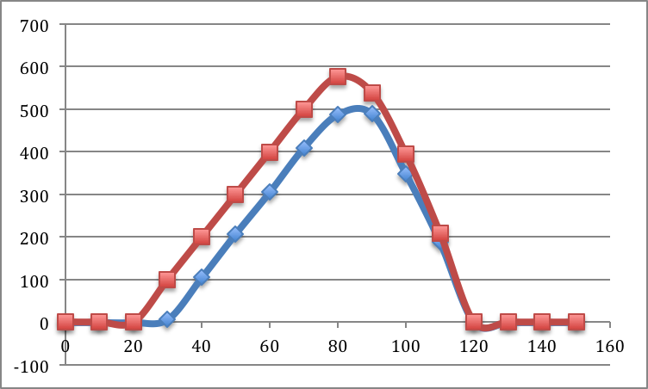

Here is the predation graph, showing that the predators really only affect the abundance and distribution of Ligia at the lower (deeper) depths.

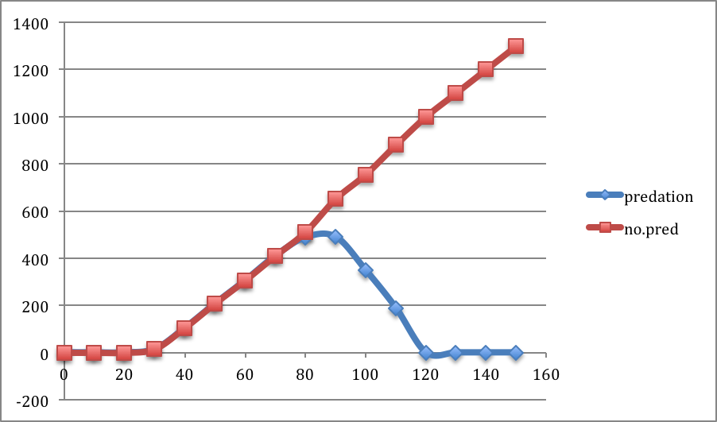

Again, the students may provide this information on 4 graphs, instead of 2.

