A species "niche" can be defined in two ways. The first is a species' role in the environment: how it interacts with other species. The second definition is more related to the needs of a species -- the niche is the biotic and abiotic factors that define where a species can exist (i.e., have a positive population growth). This second definition is closer to G. E. Hutchinson's "n-dimensional hypervolume." By this definition, the niche is the set of biotic and abiotic parameters that determine where a species can and cannot exist.

We want you to use the Excel program “LigiaNiche_2016.xls” to explore this second definition of niche, using Ligia as a study species. We have created a hypothetical ecological scenario, based on three well-known species: please recognize that this isn’t supposed to mimic any exact ecological situation. Ligia, also known as sea roach or boat bug, is an isopod that occurs in the intertidal region. It is a detritivore that feeds on vegetable remains or any other organic material. Triggerfish are a likely predator of Ligia: these fish are voracious diurnal predators. The gray triggerfish feeds primarily on benthic invertebrates such as shrimp, crabs, sea urchins,
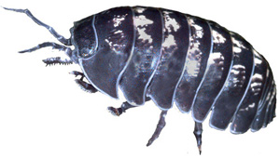
Ligia, or sea roaches, are common isopods found in the intertidal.
sand dollars, sea stars, sea cucumbers, and bivalve mollusks. So, I am sure it would love to eat Ligia. On the other hand, Gammarus is a likely competitor for Ligia. This amphipod is laterally compressed and swims on its side, typically eating organic debris that it must share with Ligia.
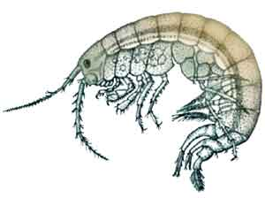
Gammarus is a common detritivore amphipod that competes with Ligia.

Your assignment is to use the excel program to conduct your own experiments to determine how competition, predation, and abiotic factors combine to determine both the abundance and distribution of Ligia. Note that there are two different questions -- factors that determine the abundance may be different than those that determine the distribution. You can directly manipulate the numbers of predators and competitors – patterns that remain when both these species have been removed can be assumed to be caused by abiotic factors.
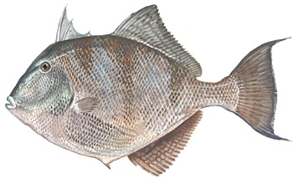
Triggerfish are common marine predators. They have an impressive set of teeth that allow them to crack the hard shells of snails and crustaceans.

Use the program to answer the following questions.
(1) What determines the upper depth limit of Ligia? (how shallow in the water they occur)
(2) What determines the lower depth limit of Ligia? (how deep they occur?)
(3) What determines the abundance of Ligia at different depths where they do occur?

You must back up your answers with evidence from experiments that you conduct using Excel. Provide graphs where appropriate to illustrate your answer (you can print graphs in excel by clicking on the graph to make it “active” then choosing print – it should allow to print only the graph or “chart”).

