Assignment 4 -- Describing Communities
PCB 3043, Fall 2016
DUE Tuesday, November 22, 2016

We want you to analyze community data, as this type of data presents important challenges for ecologists. You have two options. (1) You can collect data of your own. We are going to be fairly open about what constitutes a community; natural examples might be trees of different species in two city parks, or types of birds or ants, etc. However, you can also do something quite different; examples would be cars in two different car lots or colors of candy in bags of different kinds of candy. Please don't use these examples, but find something more original. (2) Or, you can get real data from one of several online databases. For example, both http://ecologicaldata.org and http://datadryad.org provide open databases from a variety of communities worldwide. Whether your own data or data from a prior study, it needs to meet the guidelines provided in #1 below.

You need to use the data you obtain to compare two communities of a given type using methods we present in class.

1. (2 pts.) Collect or somehow obtain a data set that has at least 50 samples or “individuals” from each of 2 different “communities.” There needs to be a minimum of 8 “species” included in each community, although not all the same species need be in the two communities. Include a copy of all your data with your assignment.

2. (8 pts.) For each community type, determine several simple community metrics:
a. Overall number of species (S)
b. Overall diversity using the Shannon-Weiner Index (H’). This index is a measure of both how many species are in the community and how evenly their abundances are distributed. It is calculated by first determining how many individuals there are in each species, then converting this to a proportion of the total number of individuals (p_{i} is the proportion of the community made up by the i^{th} species). All the p_{i}s are then used in the following formula for H’ (use natural logs):

$$H'\text{=-}\sum{p_{i}\text{ln}p_{i}}$$

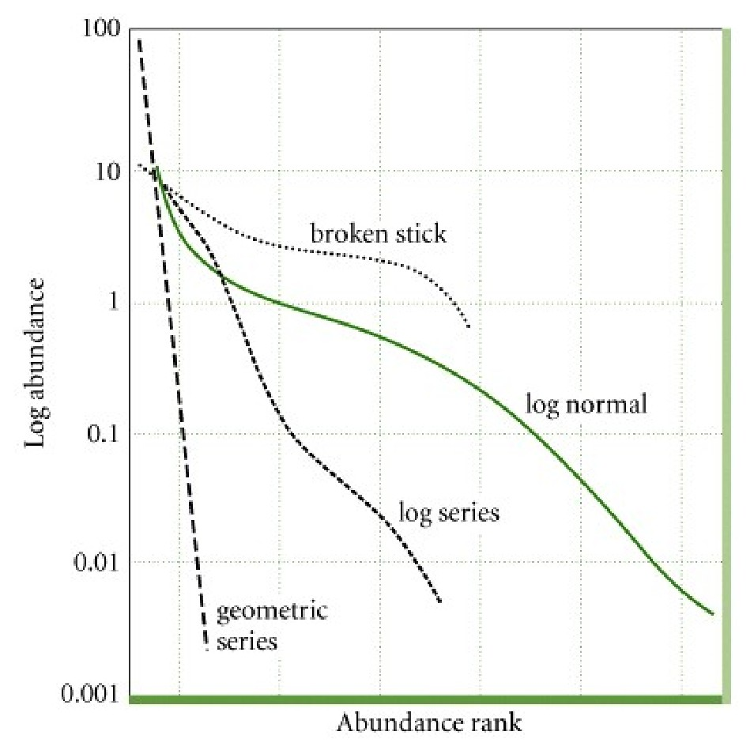
3. (5 pts.) Graphic representation of each community type.

Fix this to make it clear that you want relative abundance, not abundance. Or whatever.

Construct a rank abundance curve for each community type (remember to use log-abundance). Rank abundance curves are determined by first putting your species in order, from the most abundant to the least abundant. Then give them a rank, from 1 (most abundant) to x (least abundant), with x being the total number of species you have in each community. Finally, plot rank on the x-axis against log abundance on the y-axis.

4. (10 pts.) Tell us how your communities differ.
a. Explain what the shape of your rank abundance curves tells you about the differences between your communities in terms of number of species versus eveness. Compare this to your answers to 2a and 2b.
b. Speculate on why your two communities are similar or different with regard to diversity.

