Assignment 4 -- Describing Communities
PCB 3043, Fall 2015

We want you to analyze your own community data: collect data from two communities of a given type and compare these communities using methods we present in class. We are going to be fairly open about allowing you to use different types of communities. Natural examples might be trees of different species in two city parks, or types of birds or ants, etc. However, you can do something quite different; examples would be cars in two different car lots or colors of candy in bags of different kinds of candy. Please don't use these examples, but find something more original.

1. (2 pts.) Collect or somehow obtain a data set that has at least 50 samples or “individuals” from each of 2 different “communities.” There needs to be a minimum of 8 “species” included in each community, although not all the same species need be in the two communities. Include a copy of all your data with your assignment. (Obviously, 2 pts. for providing all the raw data)

2. (8 pts.) For each community type, determine several simple community metrics:
a. (2 pts) Overall number of species (S)
b. (6 pts) Overall diversity using the Shannon-Weiner Index (H’). This index is a measure of both how many species are in the community and how evenly their abundances are distributed. It is calculated by first determining how many individuals there are in each species, then converting this to a proportion of the total number of individuals (p_{i} is the proportion of the community made up by the i^{th} species). All the p_{i}s are then used in the following formula for H’ (use natural logs):

$$H'\text{=-}\sum{p_{i}\text{ln}p_{i}}$$

3. (5 pts.) Graphic representation of each community type.
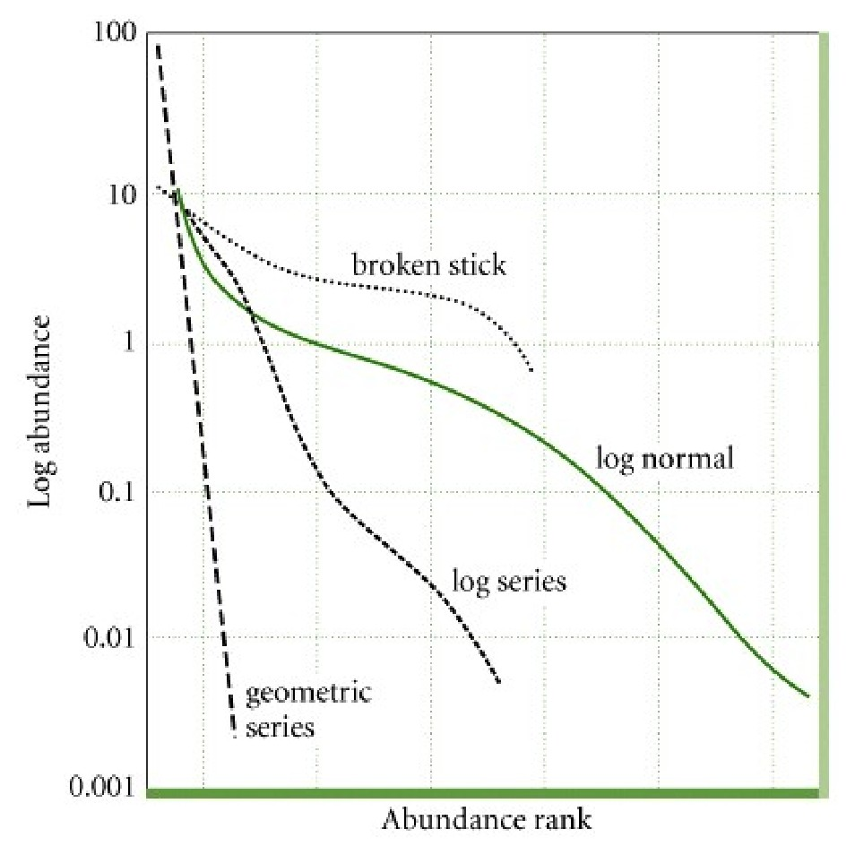
Construct a rank abundance curve for each community type (remember to use log-abundance). Rank abundance curves are determined by first putting your species in order, from the most abundant to the least abundant. Then give them a rank, from 1 (most abundant) to x (least abundant), with x being the total number of species you have in each community. Finally, plot rank on the x-axis against log abundance on the y-axis. (This can be two separate graphs and they can can use either abundance of pi, as well as log or ln. Give 2 pts. apiece for each curve plus 1 point for axes correctly labeled = 5 pts.)

4. (10 pts.) Tell us how your communities differ.
a. Explain what the shape of your rank abundance curves tells you about the differences between your communities in terms of number of species versus eveness. Compare this to your answers to 2a and 2b. (6 pts. – hopefully they tell us something about the relative contributions of richness and eveness. 2 points for writing almost anything, up to 4 more points for saying something reasonable)
b. Speculate on why your two communities are similar or different with regard to diversity. (4 pts. for any sort of speculation about mechanisms that might give different patterns. For example, with the car colors, then they might say that older people like more sedate car colors, resulting in lower richness).

