References
Boyden, E. S. (2011). "A history of optogenetics: the development of tools for controlling brain circuits with light." F1000 Biol Rep 3: 11.
This review was written by one of the co-creators of the optogenetic method. This is an essay, but it follows the thoughts and ideas for manipulating specified subsets of neurons to study brain activity and circuitry. The review doesn’t cover much of the structure of the rhodopsins, but I really liked the unique style of writing. This is a good essay that can be read quickly.

Boyden, E. S., F. Zhang, et al. (2005). "Millisecond-timescale, genetically targeted optical control of neural activity." Nat Neurosci 8(9): 1263-1268.
This is the first paper published that used optogenetics in neurons. Boyden used cultured CA3/CA1 hippocampal neurons that expressed the ChR-2 channel. Upon illumination, these neurons exhibited spike trains only during illumination and were temporally precise. Boyden also looked at the basal properties, such as resting potential and membrane resistance, of these cells and found no differences from control neurons. If you are planning on using optogenetics, this is a must-read paper!

Chow, B. Y., X. Han, et al. (2010). "High-performance genetically targetable optical neural silencing by light-driven proton pumps." Nature 463(7277): 98-102.
In response to the limitations of halorhopsin, Chow et al. published this paper providing information on a more efficient rhodopsin for neural silencing. Arcaerhodopsin was expressed in the frontal cortex of mice, and was shown to silence neurons in response to yellow light. Unlike halorhodopsin, this inhibition was near 100%, and could produce up to 900 pA of outward current. The rhodopsins also recovered from light-induced inactivation very quickly and unlike halorhodopsin, did not get stuck in the inactive state after prolonged illumination. These channels are proton pumps which pump positive ions out of the cell when activated, unlike halorhodopsin which was a chloride channel. The authors also went on to show that different light activated proton pumps could be used to silence the same set of cells in response to different wavelengths of light. Mac is another pump which is activated by blue light. This paper not only solved the inefficient halorhodopsin problem, but also suggests a novel method for studying circuitry in the awake brain.
Fenno, L., O. Yizhar, et al. (2011). "The development and application of optogenetics." Annu Rev Neurosci 34: 389-412.
Unlike the first review on the history of optogenetics, this review focused more on practical applications. It explains some of the different types of rhodopsins that are and have been used in optogenetics, giving some of the pros and cons. It also discusses the different options one would have for expressing rhodopsins in specific neuronal subtypes, e.g. lentivirus or adeno-assoicated virus, and the necessary hardware, e.g. optical probes. Once the review has explained the technique, it goes over the use of optogenetics in several different species, including the rat, mouse, zebrafish, fly and primates. The review is thorough and would be a great source to use when thinking about the use of optogenetics.
Han, X. and E. S. Boyden (2007). "Multiple-color optical activation, silencing, and desynchronization of neural activity, with single-spike temporal resolution." PLoS One 2(3): e299.
This paper characterizes the use of halorhodopsin as a neural silencer. This is the first paper published using this opsin to reduce spiking in neural tissue. Han and Boyden showed that the basal charactertistics of cultured rat hippocampal cells expressing halorhodopsin did not differ from control. When illuminated with yellow light, cells expressing halorhodopsin had reduced firing rates. The current clamp traces showed some positive deflections, but not enough to produce action potentials. Han and Boyden then went on to show that halorhodopin and channelrhodopsin 2 could be expressed in the same neural tissue. Since activation of each of these channels requires a different wavelength of light, the channels could be independently stimulated. When stimulated with blue light, ChR-2 was activated and cells spiking increased, however, when stimulated with yellow light, halorhodopsin channels were opened and cells showed a decrease in firing rates. This paper shows that optogenetics could be used to inhibit cells and that expression of different channels in the same tissue could be used to activate or inhibit neurons.

Han, X., X. Qian, et al. (2009). "Millisecond-timescale optical control of neural dynamics in the nonhuman primate brain." Neuron 62(2): 191-198.
In this paper, the researchers are using optogenetics in the rhesus macaques to study activity in the frontal cortex. They used channel-rhodopsin 2 to excite cells in the cortex and recorded from the primate brain over many trials. The ChR-2 was targeted to excitatory neurons in the area. Upon illumination, cells in the frontal cortex were either excited or expressed. This paper was important because it showed that this technique could be used in non-human primates, ChR-2 did not induce an immune response and even after many trials that were spread out over months, the cells in the frontal cortex appeared to be healthy. Again, this data supports the possibility of use in clinical trials in the future.

Kravitz, A. V., B. S. Freeze, et al. (2010). "Regulation of parkinsonian motor behaviours by optogenetic control of basal ganglia circuitry." Nature 466(7306): 622-626.
This is the paper that I presented in class. I chose this paper because it really showcases a few of the reasons that optogenetics is such a useful tool. The researchers were studying the basal ganglia circuitry in awake, behaving animals. The proposed circuitry has been studied by many other labs, but until optogenetics was developed there was no way of manipulating the complicated circuitry directly. D1 and D2 receptor expressing neurons were targeted for channelrhodopsin-2 expression. The neurons in the D1 and D2 cre-ChR2-YFP mice were in locations and behaved similarly to previous data. Upon activation via illumination of the direct pathway, the mice displayed an increase in locomotor activity, and a decrease in activity when the D2 receptors were activated. The final assay showed that motor deficits, similar to those seen in Parkinson’s, could be ameliorated by activation of the direct pathway. This could lead to use in clinical settings in the future.

Tecuapetla, F., J. C. Patel, et al. (2010). "Glutamatergic signaling by mesolimbic dopamine neurons in the nucleus accumbens." J Neurosci 30(20): 7105-7110.
Experiments using cultured ventral tegmental area and nucleus accumbens neurons suggest that dopaminergic neurons in the VTA may be increasing activity in the nucleus accumbens via release of glutamate. This has only been seen in culture, which can change the way the neurons act and is sometimes not indicative of how the cells act in intact neural tissue, however, until optogenetics there was no other way to look at this phenomenon. ChR2 was expressed in DAergic projection neurons in the VTA. When excited via illumination in slice electrophysiology, the researchers found excitatory post synaptic currents independent of dopamine signaling. These currents could also be blocked by AMPA and NMDA receptors blockade. The researchers conclude that the mesolimbic reward pathway may involve glutamatergic, as well as dopaminergic signaling.

Tye, K. M., R. Prakash, et al. (2011). "Amygdala circuitry mediating reversible and bidirectional control of anxiety." Nature 471(7338): 358-362.
What would a bibliography be without a paper on the amygdala?
This paper was interesting because it used optogenetics to look at activity in central amygdala (Ce)(medial and lateral) after stimulation of the basolateral-CeL synapses. Instead of targeting the BLA neurons at the soma, they targeted the synapse of the BLA in the CeL. ChR2 expression was localized to BLA projection neurons, but since BLA projects to many areas of the brain which may influence anxiety, Tye et al. placed the cannula for the optical stimulation into the CeL, which would excite only the BLA-CeL synapses. They found that excitation of the synapses had an anxiolytic effect on the animal, where as excitation of the BLA soma had an anxiogenic effect (more similar to previous data). One potential reason for this phenomenon is that activation of all BLA neurons could be having an effect on downstream targets, changing the final motor output. They also used inhibition via a third generation halorhodopsin channel. This paper illustrates how optogenetics can be used to study circuitry between distinct areas without affecting other areas of the brain receiving input from the area under study.
Zemelman, B. V., G. A. Lee, et al. (2002). "Selective photostimulation of genetically chARGed neurons." Neuron 33(1): 15-22.
Before the development of optogenetics, scientists were searching for a way to manipulate specified subsets of neurons, and this was one of the possibilities. “chARGe" is the term Zemelman et al. used to describe genes from a Drosophilia phototransduction cascade, Arrestin-2, rhodopsin coupled to a g-protein(ARG) that could be expressed in oocytes and cultured rat hippocampal neurons. The chARGe expressing neurons increased spike firing in response to illumination. chARGe expression can be localized to specific cell types in transgenic animals, so unlike electrical stimulation or caged compounds, one would be able to affect specific subsets of cells, while leaving others unaffected. The pitfalls of this method included that the latency to induce the increased spike firing could be anywhere from 100s of ms to 10s of seconds, and the cells expressing chARGe need to be supplied with an initial dose of retinal to function correctly. Although this paper was a big step in the right direction, it was not precise enough temporally.
Internet sources:
http://www.stanford.edu/group/dlab/optogenetics/
Karl Diessorth’s lab webpage with links to several articles and methods papers. Also has links to training courses, references, and a light transmission calculator for brain tissue. This is the website to visit if you would like to use this technique in your research.
http://www.ted.com/talks/gero_miesenboeck.html
This is a Ted Talk from Gero Miesenboeck. Gero Miesenboeck published a paper in 2002 where they activated neurons by trasfecting a Drosophilia phototransduction cascade in neurons, then exposing these cells to light. This talk was interesting and quite funny, but he doesn’t go into much detail on his methods. This shows another area of neuroscience where optogenetics is being used, Drosophilia decision making.
http://www.ted.com/talks/ed_boyden.html
This Ted talk is given by Edward Boyden on optogenetics. This is a great review on some of the history of the development of optogenetics. It also goes over a bit of the methods of optogenetics, but this is pretty brief.

http://syntheticneurobiology.org/protocols
This is webpage that is kept up to date by Edward Boyden and functions as his lab homepage. This site has links to the research in his lab, and even many of the protocols they use in this research.
http://www.buffalo.edu/news/12926
This is an article from the University of Buffalo. It briefly describes the use of magnetism to manipulate neural activity. Similar to optogenetics in that it can target specific cells types, but it is less invasive since magnetic pulses from outside of the animal can activate the channels. This could be one of the next big neuro methods.
http://www.nature.com/nature/videoarchive/braincellonoffswitch/
Nature videos on optogenetics. The video includes an interview with Karl Deisseroth on the application of optogenetic tools, especially halorhodopsin as a neural silencer.
http://www.youtube.com/watch?v=I64X7vHSHOE
This short video is originally from Nature Videos. It includes information on how to virally transfect neurons with rhodopsin. It also includes videos from papers published on many different species, including mice (neural and cardiac), drosophilia, and c. elegans, and even skin cells.
http://www.scientificamerican.com/article.cfm?id=optogenetics-controlling
This is a 2010 article written by Karl Deisseroth. It includes a bit of his take on how optogenetics was discovered, and includes some of the applications that optogenetics has been used for, including the Parkinson’s paper I presented in class.
http://en.wikipedia.org/wiki/Optogenetics
This is a pretty good general review.
http://sfari.org/news-and-opinion/news/2011/optogenetics-study-boosts-signal-imbalance-theory-of-autism
This article is looking at the potential causes for autism spectrum disorder. The article discusses the use of optogenetics to stimulate activity in the prefrontal cortex of mice to study the hypothesis that individuals with autism (and schizophrenia) may have altered gamma oscillations.
http://f1000.com/search/faculty?query=optogenetics&selectedDomain=all
The Faculty of 1000 website has 6 professors that work with optogenetics. This page has links to information on all of them, including Ed Boyden.
http://ttv.mit.edu/videos/13093-optogenetics-a-light-switch-for-neurons
Video from MIT on optogenetics. The video is pretty easy to understand for all levels of neuroscience interest. The graphics are also stunning so it is a neat video to watch.

http://www.uctv.tv/search-details.aspx?showID=4243
Interview with Francis Crick.

http://www.youtube.com/watch?v=QA67v4vSg00
Youtube animation and interview
http://sfari.org/news-and-opinion/news/2011/optogenetics-study-boosts-signal-imbalance-theory-of-autism
http://ttv.mit.edu/videos/13093-optogenetics-a-light-switch-for-neurons
Video from MIT on optogenetics
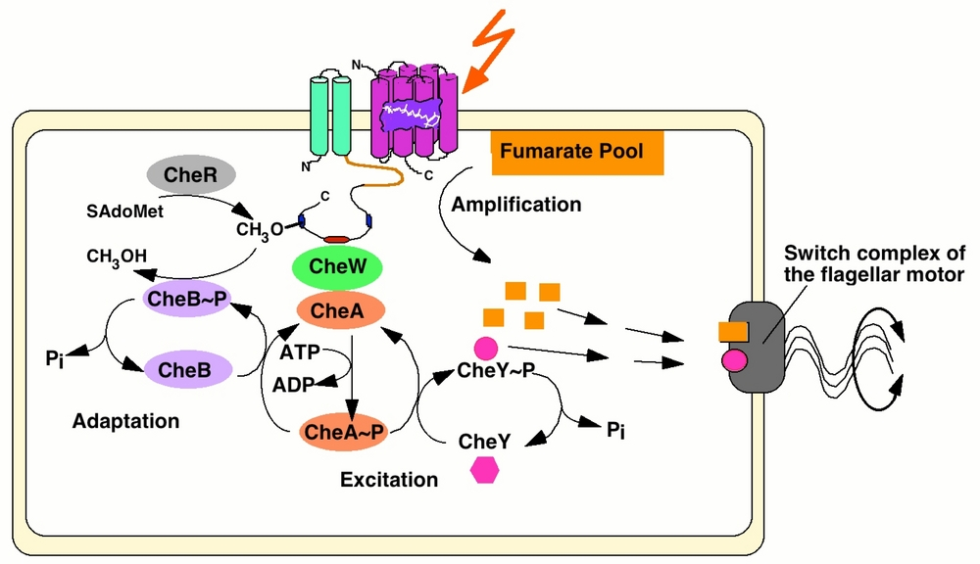 http://www.mpi-magdeburg.mpg.de/research/groups/mna/smallnet.html?pp=1

History of Optogenetics
Faculty of 1000

