Annotated Bibliography 1
Calcium and Non-Selective Channels
- Voltage-Gated Calcium Channels
http://cshperspectives.cshlp.org/content/3/8/a003947.full?sid=8e5d9217-0d9c-45cc-9671-025dab573a81
-Are key transducers of membrane potential changes into intracellular Ca transients that begin physiological events
-10 members of the voltage-gated family in mammals and serve distinctive roles
- Cav1 subfamily: initiates contraction, secretion, regulation of gene expression, integration of synaptic input in neurons, and synaptic transmission at ribbon synapses in specialized sensory cells.
- Cav2 subfamily: initiates synaptic transmission at fast synapses
- Cav3 subfamily: important for repetitive firing of action potentials in rhythmically firing cells such as cardiac myocytes and thalamic neurons
Physiological roles of voltage-gated Ca channels:
- Activate on membrane depolarization and mediate calcium influx in response to A.P.s
- In cardiac and smooth muscle cells, activation of Ca channels initiates contraction directly by increasing cytosolic Ca concentration and indirectly by activating calcium-dependent calcium release
- In skeletal muscle cells, Cav channels interact directly with ryanodine-sensitive Ca release channels to initiate rapid contraction
- In neurons, Cav channels initiate synaptic transmission
- Cav channels are the KEY signal transducers of electrical excitability, converting the electrical signal of the action potential in the cell surface membrane to an intracellular Ca transient
Current Types Defined
- L-type: slow voltage-dependent inactivation and therefore are long lasting when Barium is the current carrier and there is no Ca-dependent inactivation
  - In endocrine cells they initiate release of hormones
  - In neurons they regulate gene expression, integrate synaptic input and initiate neurotransmitter release at specialized ribbon synapses in sensory cells
  - Subject to regulation by second messenger-activated protein phosphorylation in several cell types…starts talking about results from 2.
- Analysis of the effects of other peptide toxins revealed three additional Ca current types
- P-type: first recorded in Purkinje neurons, are distinguished by high sensitivity to the spider toxin w-agatoxin IVA
- Q-type: first recorded in cerebellar granule neurons, are blocked by w-agatoxin IVA with lower affinity
- R-type: in cerebellar granule neurons are resistant to most subtype-specific rganic and peptide Ca channel blockers and may include multiple channel subtypes
  - Can be blocked selectively in some cell types by the peptide SNX-482 derived from the tarantula Hysterocrates gigas
- Although L-type and T-type are recorded in a wide range of cell types, N-,P-,Q- and R-type Ca are most prominent in neurons
Molecular Properties of Ca Channels
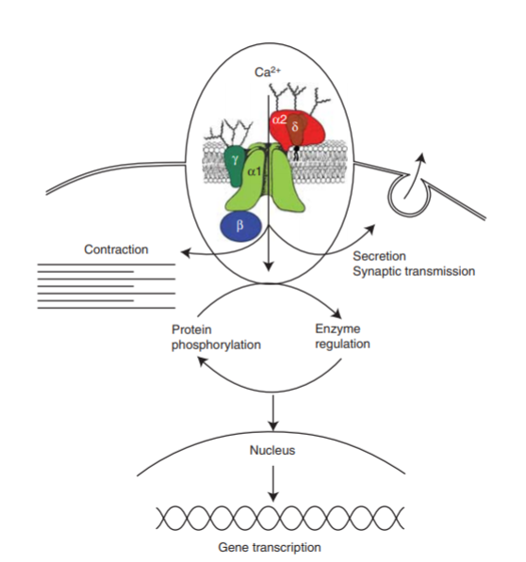
Subunit Structure:
- Alpha1 subunit is a protein of about 2000 amino acid residues in length with an amino acid sequence and predicted transmembrane structure like the previously characterized pore-forming alpha subunit of voltage gated sodium channels.
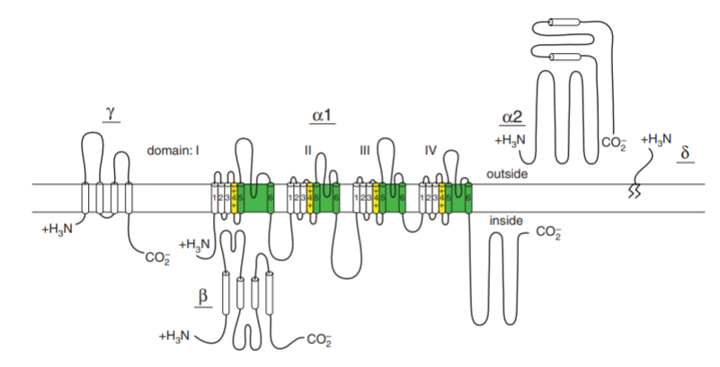
- The aa sequence is organized in four repeated domains, with each containing 6 transmembrane segments and a membrane-associated loop between transmembrane segments S5 and S6.
- The intracellular Beta subunit has predicted alpha helices but not transmembrane segments, whereas the gamma subunit is a glycoprotein with four transmembrane segments
- The cloned alpha 2 subunit has many glycosylation sites and several hydrophobic sequences- but it is an extracellular, extrinsic membrane glycoprotein, attached to the membrane through disulfide linkage to the delta subunit
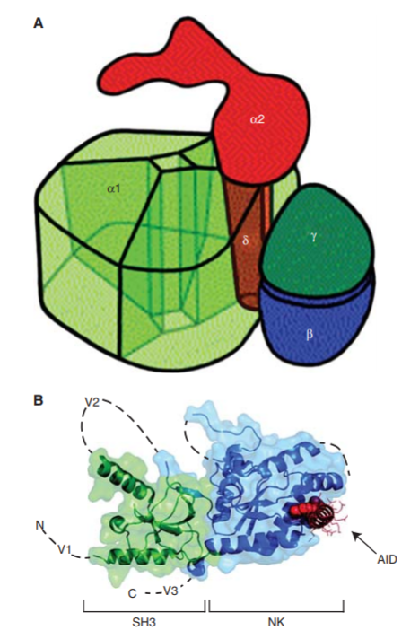
Functions of Calcium Channel Subunits
Calcium Channel Diversity
- Different types of Ca currents are primarily defined by different alpha1 subunits, and 10 different ones (3 subfamilies Cav1, Cav2, Cav3) have been characterized by cDNA cloning and functional expression
- Cav1: mediate L-type Ca currents, have about 75% aa sequence identity among them
- Diversity of Ca channel structure is enhanced by multiple Beta subunits (4 B subunit genes have been identified, and each is subject to alternative splicing to yield additional isoforms
- Cav1 channels: serve to couple depolarization of the plasma membrane to a wide range of cellular responses
Molecular Basis for Ca Channel Function
- S4 segments of each homologous domain serve as the voltage sensors for activation, moving outward and rotating under the influence of the electric field and initiating a conformational change that opens the pore
- S5 and S6 segments and the membrane-associated pore loop between them form the pore lining of the voltage-gated ion channels
- The narrow external end of the pore is lined by the pore loop, which contains a pair of glutamate residues in each domain that are required for Ca selectivity (unique feature of Ca channels)
- Only 3 glutamate residues in the pore loops btwn S5 and S6 in domains II, III, IV of sodium channels are sufficient to confer Ca selectivity
- Inner pore is lined by S6 segments, which form receptor sites for the pore-blocking Ca antagonist drugs specific for L-type Ca channels
Cav1 Channels in Excitation-Transcription coupling
- Ca entering neurons through L-type Ca currents (conducted by Cav1 channels) has a privileged role in regulation of gene transcription
  - Might arise from preferential localization (which could provide Ca in the vicinity of transcriptional regulators), preferential interaction with binding partners (which could be activated by local Ca entry and carry the regulatory signal to the nucleus) or nuclear targeting of a subunit or domain of the Cav1 channel itself (would serve to regulate transcription directly)
  - Likely that all 3 of these mechanisms are involved
- Cav1 channels are localized in higher density in the cell bodies and proximal dendrites of neurons compared to Cav2 and Cav3 (more prevalent in nerve terminals and dendrites)
  - This preferential localization would favor Ca entry through these channels in control of transcription in the nucleus
- Only a local increase in Ca is required for up-regulation of transcription in neurons
  - Suggests that specifically bound Ca dependent regulatory proteins may respond to local Ca entering via Cav1 channels and regulate transcription
    - Calmodulin binding to the proximal carboxy-terminal domain of Cav1.2 channels is required for regulation of transcription in neurons (thus calmodulin itself may serve as a regulator by binding local Ca, changing conformation to the active form and moving to the nucleus)
      - However there are large pools of free and Ca-bound calmodulin throughout the cell, so additional mechanisms must be engaged to specifically move Ca/calmodulin complexes from the Cav1 channels to the nucleus in the context of this mode of regulation
    - Calcineurin bound to the distal carboxy-terminal domain of Cav1 channels also is a potential transcriptional regulator through de-phosphorylation of the nuclear factor of activated T cells (NFAT) by calcineurin bound to Cav1.2 channels induces its dissociation, movement to the nucleus and regulation of transcription
      - This seems to have all of the right elements for selective regulation of gene transcription by Ca entering neurons via Cav1.2
    - The distal carboxy-terminal domain of the Cav1 channel itself may be a transcriptional regulator
    - The large carboxy-terminal domain of Cav1.1 and Cav1.2 channels is proteolytically processed in vivo near its center, leaving a non-covalently associated distal carboxy-terminal domain of more than 300 residues intact to regulate channel activity
Cav1 Channels in Excitation-secretion Coupling
The Effector Checkpoint Model of Ca Channel Regulation
- Ca channel signaling complexes are formed when the effectors and regulators of the Ca signal bind to the intracellular domains of Ca channels to effectively receive and respond to the local Ca signal
- 4 cases have shown to enhance activity of Cav1 and Cav2 channels
  - Skeletal muscle: interactions of plasma membrane Cav1.1 channel with the ryanodine-sensitive Ca release channel in the sarcoplasmic reticulum which serves as the effector of excitation-contraction, greatly increase function activity of Cav1.1

- Different Types of Calcium Channels
http://jeb.biologists.org/content/124/1/177.long
Calcium channels allow passage of ions into the cytoplasm through a selective pore that is opened in response to depolarization.

Calcium can:
- Create a net inward, depolarizing current
- Act as a chemical trigger for secretion of hormones and neurotransmitters along with more calcium-sensitive events
- Can be both an electrical signal and an intracellular chemical messenger (unique to the family of ion channels)
Understanding these channels can be traced to Susumu Hagiwara: 1975 work published on starfish eggs distinguishes two calcium current components by steady-state inactivation, activation threshold and selectivity
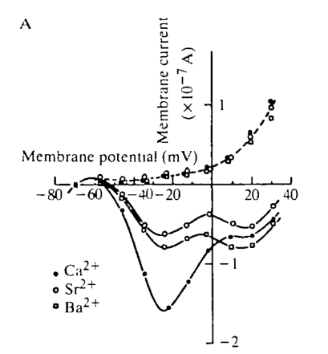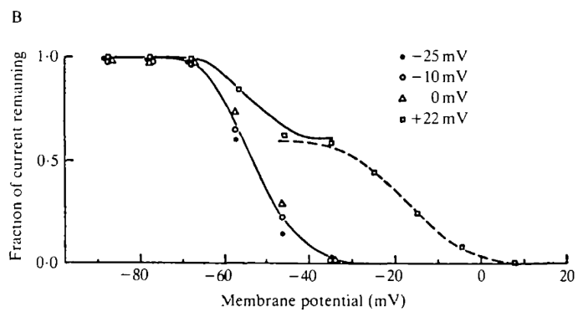
- A: The solid curves have to local minima which imply there are two currents at play activating at two different voltage values (Type I and Type II). The curve crossing indicates that the two currents have selectivity
- B: Represents different inactivation properties of the two currents. Triangles and circles activate Type 1; Squares should activate both Type 1 and 2
The properties of different activation thresholds and different inactivation ranges have been applied to: starfish eggs, tunicate eggs, Neanthes worm eggs, inferior olivary neurons, neuroblastoma cells, rat hippocampal neurons, dorsal root ganglion neurons, GH_3 and GH_4 cells, sensory cranial neurons, rat olfactory neurons, etc…
Three Calcium Channel Types on DRG Neurons
Whole cell
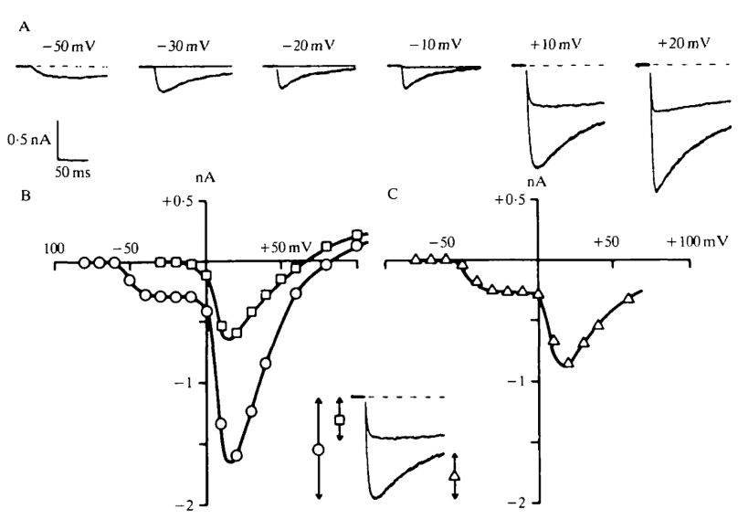
Nowycky et al. (1985): Pulses from a holding potential of -40 mV elicit a non-inactivating current (A) represented by squares on the current-voltage curve (B)
- The prolonged current has been called the ‘L’ (for ‘Long-lasting, Large Barium conductance) and ‘HVA’ (High Voltage-Activated)
From holding potential of -100 mV, pulses to negative potentials elicit a current which inactivates completely and appears to reach its max amplitude near -10 mV
- This has been called ‘T’ (for transient, tiny barium conductance) and ‘LVA’ (for low voltage-activated)
Pulses to positive potentials from the -100 mV holding potential elicit, in addition to the non-inactivating L current, an inactivating current of larger amplitude than the T-type current. It’s similar to T bc it inactivates and requires a negative holding potential but is like L in the voltage range of activation
C: Plots fraction of current which relaxes during the pulse- peaks at -10 and 20 mV. Authors claimed 20 mV was due to a 3rd calcium channel type called ‘N’ bc it needs proof that it is from neither T nor L currents.
Single channels
Used on-cell patch method to distinguish 3 different types of calcium channels
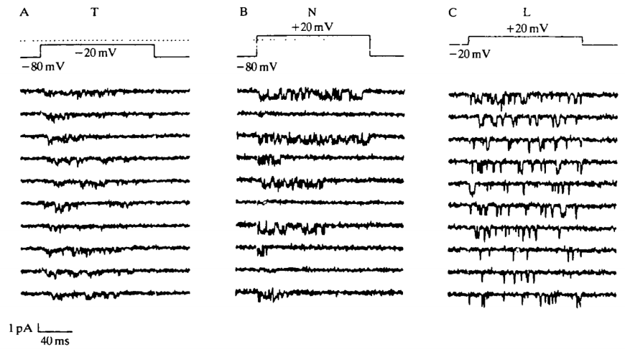
- A: small-conductance channel activated with a protocol appropriate for T (activity is bunched towards the beginning of the pulse- expected of an inactivating current)
- C: large-conductance channel activated from a depolarized holding that only allows L-type (openings scattered evenly throughout pulse- expected for a non-inactivating channel)
- B: shows a channel activated with pulses to positive potentials from a hyperpolarized holding potential as expected for the putative N channel. Has distinctly larger single-channel amplitude that T yet its activity is towards the beginning of the trace, unlike L (single channel conductance is half of L channel and greater than T channel)
Function of Different Calcium Channel Types
L-Type
- Clearly serve both electrical and chemical functions during the heartbeat
- Only very slow inactivation of L channels allows the maintained calcium current that underlies the plateau phase of the cardiac action potential
- The calcium entering the cell through L channels is necessary both for replenishing calcium stores of the sarcoplasmic reticulum and possibly for triggering intracellular calcium release
T-type
- A study of inferior olivary neurons demonstrated rapid calcium action potential that could be induced only if the cell was hyperpolarized. This T-like activity would be inactive at all times except during the after-hyperpolarization that follows a burst of action potentials and it was proposed that the conductance helped control the duration of the interburst interval
- A full cycle of bursting would utilize two different calcium channels in different ways: the action potential is qualitatively like that in cardiac cells in that it consists of a sodium spike followed by a prolonged calcium plateau caused by a non-inactivating, L-like conductance. A burst of such spikes is terminated when the accumulation of intracellular calcium sufficiently activates a calcium-dependent potassium conductance. The after-hyperpolarization caused by the increased potassium conductance would unmask the T-type channels which re-prime excitability and help trigger the succeeding burst. Thus, T-type channels play a crucial electrical role in neuronal coding
N-type
- Tempting to suggest that these channels serve a neuron-specific function since they have only been demonstrated in nerve. Could the N channel be responsible for neurotransmitter release from presynaptic terminals?
- Toxin-sensitive, N-like channels are a candidate for mediating release in sympathetic neurons whereas dihydropyridine-sensitive, L-type channels seem to be ruled out. Overall, pharmacological data suggest that the identity of the channel responsible for neurotransmitter release may be L in some tissues and N in others. If so, w-CgTX, which blocks both L and N channels in neurons but fails to block L channels in muscle, seems ideally designed to inhibit presynaptic release
- Structural basis for Ca2+ Selectivity of a voltage-gated calcium channel
https://www.ncbi.nlm.nih.gov/pubmed/24270805 (yes)
- Since extracellular concentration of Na is 70-fold higher than Ca, biological functions (contraction, secretion, neurotransmission, gene expression, etc.) require Cav channels to be highly selective for Ca in preference to Na even though Ca and Na have nearly identical diameters
  - It could be selective bc of the high affinity binding of Ca, which prevents Na permeation
  - Fast Ca flux through Cav channels is thought to use a ‘knock-off’ mechanism in which electrostatic repulsion btwn Ca ions within the selectivity filter overcomes tight binding of a single Ca ion. (most mechanisms require a multi-ion pore, but extensive mutational analyses of ion selectivity and cation block of vertebrate Cav channels supports a single high-affinity binding site)
- Cav channels contain a single ion-selective pore in the center of four homologous domains
  - Central pore lined by S5 and S6
  - Voltage sensing modules S1-S4
  - Channels are closely related to Nav channels
    - 3 structures of homotetrameric bacterial Nav channels open the way to elucidating the structural basis for ion selectivity and conductance of vertebrate Nav and Cav channels, which probably evolved from the bacterial NaChBac family and retained similar structures and functions
    - Mutations of 3 aa residues in the selectivity filter of NaChBac is sufficient to confer Ca selectivity
Structure and function of CavAb
- NavAb channels have four identical pore motifs that form the ion selectivity filter
- NavAb channels does not conduct extracellular Ca ions but carries outward Na current
  - CavAb conducts inward Ca current in a voltage-dependent manner
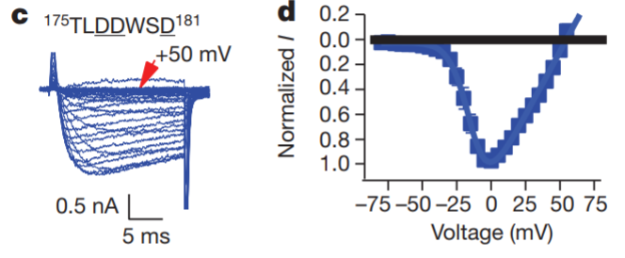
- Voltage dependent conductance of inward Ca current by CavAb under the same conditions as a,b. 20-ms 5-mV step depolarizations
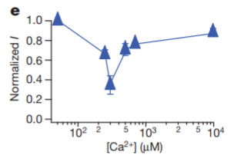
- Biphasic anomalous mole fraction effect of increasing Ca as indicated, with Ba as the balancing divalent cation
- These results demonstrate the anomalous mole fraction effect characteristic of vertebrate Cav channels.
  - The reversal potential for Ca current under bi-ionic conditions closely follows the expectation for a highly Ca-selective conductance.
- They also crystallized and determined the structure of CavAb and its derivatives by molecular replacement. The overall structure of CavAb is very similar to that of NavAb and the Ca selectivity of CavAb is mainly determined by the side chains of the aa at the selectivity filter
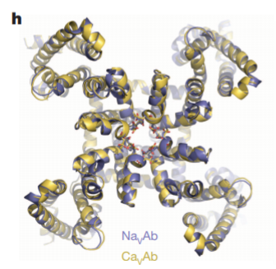
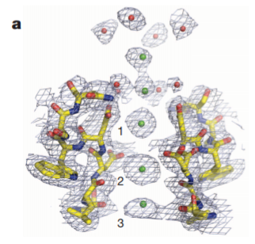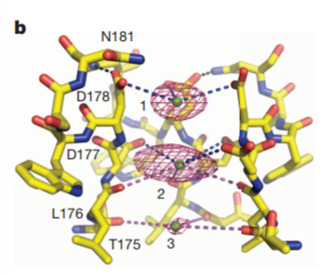
- Two strong peaks followed by a weaker peak on the intracellular side were found in the selectivity filter along the ion-conduction pathway, verifying three binding sites for Ca (Site 1, Site 2 and Site 3 from the extracellular to the intracellular side)
  - Site 1 is predominantly coordinated by the carboxyl groups of D178 which define a plane at the selectivity filter entrance on the extracellular side of the bound Ca ion
  - The chemical environment of Site 3 hints at a lower affinity, consistent with its role in exit of Ca from the selectivity filter into the central cavity
Block of NavAb and CavAb channels by divalent bonds
- Cd, Mn and other inorganic cations are effective blockers of Cav channels
  - They both bind in the selectivity filter of Site 2 (central site) and inhibit the Ca current by competitively binding to the high-affinity site required for Ca permeation
Ion binding at the Ca selectivity filter
- The central site has the highest affinity, but Site 3 is the weakest
  - Probable that this titration pattern reflects independent binding of Ca to Sites 1, 2 and 3 located in different individual molecules of CavAb at low Ca concentration
  - Increasing concentrations of Ca saturate Site 2 in most or all individual CavAb molecules and reduce or eliminate binding at Sites 1 and 3 by repulsion
  - The two flanking sites have lower affinity than the central site (as proposed by the ‘stepwise binding model’ of Cav channel permeation)
Ion permeation mechanism
- It is energetically unfavorable for Ca ions to occupy adjacent sites simultaneously
- Hypothesis: two interchangeable functional states of the selectivity filter in the crystal structure
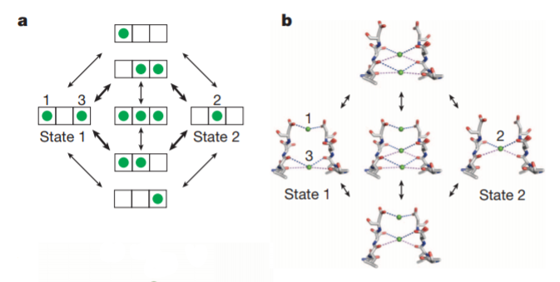
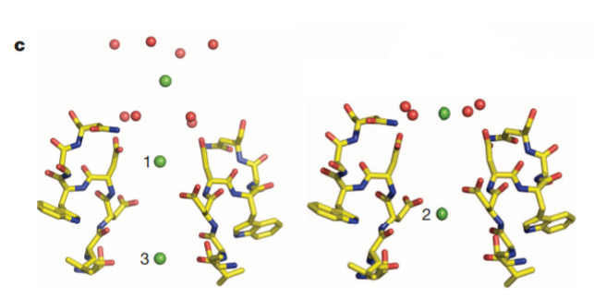
- Bc of high concentration of Ca in the extracellular solution, Ca will prefer to enter site 1 and the weak binding of site 3 will force loss of Ca into the low Ca concentration in the cytosol
  - Gives unidirectional flux of Ca into the cell
- The 3 ion occupied state would manifest only when the external Ca concentration is increased enough that the flux reaches a limiting value

- Molecular Mechanism of Calcium Channel Regulation in the Fight-or-Flight Response
http://stke.sciencemag.org/content/3/141/ra70.full (maybe)
- Fight or Flight: conserved behavior of vertebrates experiencing fear, stress or intense exercise
- Adrenal medulla releases epinephrine and sympathetic nerve releases norepinephrine activating Beta-adrenergic receptors and leads to an increase in L-type calcium currents in cardiac and skeletal muscle (increases force of contraction of skeletal muscle and beating rate and contractility of heart)
- Regulation of L-type calcium currents happens bc activation of protein kinase A (PKA)-mediated phosphorylation but the molecular mechanism is unknown
- In this paper they identify sites of protein phosphorylation that are both necessary and sufficient for physiological regulation of Cav1.2 channels in non-muscle cells. These sites are located at the interface between the proximal (PCRD) and distal (DCRD) C-terminal regulatory domains (well positioned to mediate disinhibition of the auto-inhibitory signaling complex and increase Ca1.2 channel activity in the fight-or-flight response
- They assessed channel activity by measuring peak Ba current and by determining the coupling efficacy of pore opening to gating charge movement. Gating charge movement was measured by integrating the gating current during depolarization to the reversal potential. Pore opening was measured from tail currents upon repolarization from reversal potential
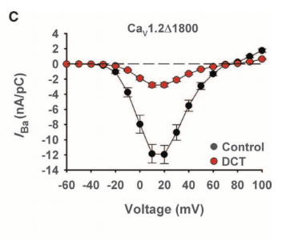
- Inward Ba current conducted by Ca1.2 channels were decreased when DCT was present
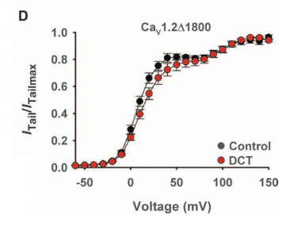
- The shift in voltage-dependent activation to more depolarizing potentials observed with large amounts of distal was barely detectable (but still significant) with smaller amounts of DCT
- This implies that optimal 0.5:1 molar ratio of the cDNAs encoding DCT and Ca1.2delta1800 causes a specific reduction in coupling efficiency of gating charge movement to pore opening.
-They also found that that PKA overexpression ensures that an AKAP15-PKA complex associates with each Cav1.2delta1800+DCT channel to mediate forskolin-dependent modulation
- They found regulation of basal activity of Cav1.2FL is similar or greater than Cav1.2delta1800+DCT, but up-regulation by PKA is substantially reduced in channels with the distal C terminus covalently attached.
- There is a difference in PKA phosphorylation of Ser^(1700) between Cav1.2FL and Cav1.2delta1800+DCT channels. Evidntly Ser^1700 is a substrate for basal PKA-dependent phosphorylation of Cav1.2 channels in transfected cells, but the increase in PKA phosphorylation of Ser^1700 is blocked by covalent association of the distal C terminus in Cav1.2FL
- They found that the basal Cav1.2 channel activity depends on phosphorylation of Thr^1704 and Ser^1700 but not on phosphorylation of Ser^1928
- It is helpful to understand how these channels are regulated because any dis-regulation can cause Timothy syndrome, a multifaceted disease in which mutations that impair voltage-dependent inactivation cause arrhythmia, developmental abnormalities an autism spectrum disorder.

- Nonselective Cation Channels. Multiple Functions and Commonalities
http://www.plantphysiol.org/content/128/2/327
- Plant ion channels that select poorly between cations have been investigated because they may act as pathways for sodium entry into plant cells under salinity stress
- These channels are called nonselective cation channels (NSCCs) or voltage-independent channels (VICs)
  - The latter reflects the relatively low dependence of gating on membrane voltage in these channels
- NSCCs have been identified from patch-clamp studies on cereals (Amtmann and Sanders, 1999)
  - Basically the similarity between the sensitivities to external Ca for Na influx into roots and Na currents, either through single channels or across the plasma membrane, suggested that a big component of Na influx could be accounted for by NSCCs.
- Approximately one-half of the Na currents observed in Arabidopsis root cells could be inhibited directly by cyclic nucleotides
  - Different responses with different cyclic nucleotides suggesting more than one type of cyclic nucleotides in intact Arabidopsis plants
  - Don’t know if these channels are the same as those sensitive to external Ca
- Another way to establish NSCC function:
  - Eliminate various cadidates (HKT1) using knockout mutations.
  - There are 20 putative cyclic nucleotide-gated channels in the Arabidopsis genome and 20 Glu receptor family genes that may form NSCCs (will take a long time)
- Root cells may seem to be an odd place for NSCCs because, as a first line of defense, cation uptake by roots would be expected to be selective
  - Roots do acquire cations non-selectively when they are cation deficient and osmotic stress may also have this effect
- For other cells where selectivity is provided by “upstream” transporters, the function of NSCCs may be as a general nutrient release mechanism
- Non-selective cation channels, transient receptor potential channels and ischemic stroke
https://www.ncbi.nlm.nih.gov/pubmed/17446049
Introduction
- Mechanisms implicated in cell death (CNS ischemia and stroke)
  - Excitotoxicity
  - Oxidative stress
  - Apoptosis
  - Oncotic (necrotic) cell death
- Each mechanism is thought to propagate through largely distinct, mutually exclusive signal transduction pathways
  - Each mechanism requires cation influx into neural cells
  - Unchecked influx of Na gives rise to oncotic cell swelling (cytotoxic edema) leads to oncotic cell death
  - Unchecked influx of Ca can trigger apoptotic and necrotic cell death
    - Since cation channels are responsible for cation influx, cation channels are key to life-death processes in neural cells during ischemic stroke
- Variety of channels have been implicated in neural cell death induced by ischemia/hypoxia
  - Highly permeant to cations (Na and Ca) as well as non-selective cation (NC) channels
- In ischemic stroke: much attention has been directed to dihydropyridine-sensitive L-type voltage-dependent Ca channels (Cav1.2) but blocking this channel in patients with acute ischemic stroke has shown little benefit
- Best studied channels in ischemic stroke belong to the group of receptor operated cation channels opened by glutamate (NMDA and AMPA receptor channels involved in excitotoxic cell death)
  - Targeting these mechanisms has been disappointing
  - Research is pointing to glutamate receptor-independent NC channels
  - NC channels may also be responsible for secondary cell death caused by endothelial dysfunction
- Purpose of this review it to examine evidence that NC channels, including TRP channels, are involved in CNS ischemia and ischemic stroke
- First they review potential involvement of two important, recently identified NC channels that are up-regulated by ischemic stroke (ASIC and the SUR1-regulated NC_Ca-ATP channel), then they consider studies using non-specific NC channel blockers (pinokalant, fenamates, rimonabant), finally they consider evidence for involvement of NC channels of the TRP family, reviewing not only data documenting their role in neuronal death and their up-regulation in cerebral ischemia
- P/Q Type Calcium Channel Cav2.1 Defines a Unique Subset of Glomeruli in the Mouse Olfactory Bulb
https://www.ncbi.nlm.nih.gov/pubmed/?term=7.%09P%2FQ+Type+Calcium+Channel+Cav2.1+Defines+a+Unique+Subset+of+Glomeruli+in+the+Mouse+Olfactory+Bulb
- Cav channels are a prereq for signal transmission at the first olfactory sensory neuron (OSN) synapse w/in the glomeruli of the main olfactory bulb (MOB)
- In this paper they identify a distinct subset of glomeruli in the MOB of adult mice that is characterized by expression of the P/Q-type channel subunit Cav2.1.
- Immunolocalization shows that Cav2.1+ glomeruli reside predominantly in the medial and dorsal MOB and in the vicinity of the necklace glomerular region close to the accessory olfactory bulb
- Cav2.1 labeling of glomeruli colocalizes with the presynaptic marker vGlut2 in the axon terminals of Osns
- Electron microscopy shos that Cav2.1+ glomeruli receive axonal input from OSNs that express molecules of canonical OSNs: olfactory marker proten, the ion channel Cnga2 and the phosphodiesterase Pde4a
- In the main olfactory epithelium, Cav2.1 labels a distinct subpopulation of OSNs whose distribution mirrors the topography of the MOB glomeruli, that shows the same molecular signature, and is already present at birth. Together, these experiments identify a unique Cav2.1+ multiglomerular domain in the MOB that may form a previously unrecognized olfactory subsystem distinct from other groups of necklace glomeruli that rely on cGMP signaling mechanisms.
- The mammalian olfactory system exhibits a highly complex organization that comprises several anatomically segregated chemoreceptive organs: MOE, VNO, GGN
- MOE & GGN
  - Project their axons to the main olfactory bulb (MOB)
- Vomeronasal sensory neurons (VSNs)
  - Project to a specific nucleus located posterior to the dorsal MOB known as the accessory olfactory bulb (AOB)
    - Understanding olfactory subsystems is key in understanding the processing of chemosensory information and the role each subsystem plays in odor-guided behaviors
- Here they present evidence for the existence of a novel multi-glomerular domain in the mouse MOB that may represent a previously unrecognized olfactory subsystem.
- This subsystem is differentiated by the expression of the Cav channel subunit Cav2.1. P/Q (Cav2.1) and N (Cav2.2) have been identified to conduct Ca currents that initiate synaptic transmission. Neurotransmitter release at central synapses is primarily mediated by high-voltage activated Ca channels (Cav2.1 and Cav2.2)
- In olfactory system both subunits have been identified in the olfactory mucosa using RNA techniques and Western blot analyses
- Presynaptic Cav2.2 protein is present in vast majority of glomeruli MOB and AOB and plays a role in neurotransmitter release
- Here they show Cav2.1 represents a second candidate for olfactory signal transmission within a distinct subset of MOB glomeruli
- To assess if P/Q-type channel subunit Cav2.1 represents a second calcium channel involved in synaptic transmission at the first olfactory synapse they conducted a systematic immunohistochemical analysis of the olfactory bulb of an adult mouse
- Analyzed whole-mount preparations (N=9) and tissue sections anterior-to-posterior and medial-to-lateral axes of MOB (N=13)
- Whole-mount staining of olfactory bulbs revelaed robust Cav2.1 immunoreactivity in small set of glomeruli and their afferent axon bundles (1)
- Negative control reactions using Cav2.1 antibody that was blocked with its cognate peptide lacked immunoreactivity
- Most prominent is the semicircular arrangement- this part of MOB contains necklace glomerular region innervated by OSNs and GGNs which both employ non-canonical second messenger pathways
  - Also larger
- N-type Ca channel Cav2.2 was found in anterior MOB but Cav2.1 was NOT found
- Created maps to analyze Cav2.1 expression in the MOB in more detail they created glomerular maps using 3D reconstruction
- A) reconstruction from a 4 month old mouse with 20 glomeruli on left and 17 on right
- C) Two other reconstructions (18 \pm 1 in left hemi and 21 \pm 4 bulbs in right hemi)
- This labeling shows that Cav2.1 immuno-labeling reveals a subset of olfactory glomeruli in the MOB that defines a specific domain
- Want to know whether glomerular Cav2.1 staining solely originates from the OSN presynaptic boutons or also from post-synaptic membranes of mitral and tufted cells that form synapses with OSN axon terminals in glomerular neuropil
- Top panels: looking for immunoreactivity (red)
- Second panels: looking for Cav2.1
- (A,B) merge, presynaptic markers OMP and vGlut2 colocalize with Cav2.1 yielding the yellow fluorescence signal
- (C,D) merge, post-synaptic dendritic markers Map2 and vGlut1 do not colocalize with Cav2.1 (separate red and green signals, no yellow)
- OSN axon terminals show robust immunoreactivity and formed typical asymmetrical synapses with post-synaptic mitral cell dendrites that were devoid of any staining
- W/in a glomerulus there was no evidence of unlabeled OSN terminals proximal to labeled OSN terminals suggesting Cav2.1 is homogeneously expressed by the axons innervating these glomeruli
- Ultrastructural features of Cav2.1-labeled and unlabeled OSN terminals in neighboring glomeruli were undistinguishable
- Vesicle density, organization of pre- and post-synaptic membrane specializations and the distribution of mitochondria were remarkable
- THUS, localization of Cav2.1 in the signal transmission and transmitter release at the first olfactory synapse of these glomeruli
- Examples of Cav2.1+ OSN terminals (ONT) establishing asymmetric synapses with unstained and electron lucent dendrites (D) are shown. Arrows (red) indicate the polarity of the synapses. Labeled axonal terminals were evident from the accumulation of the DAB precipitate among the presynaptic vesicles and membrane specializations. There was also a typical darkening of mitochondrial membranes in labeled terminals. In Cav2.1+ glomeruli, only ONT are visible suggesting that Cav2.1 is homogeneously expressed by the axons innervating glomeruli.
- Immunoreactivity (red), endogenous GFP fluorescence in whole mount MOB prep of an adult OMP-GFP mouse. Cav2.1 and GFP colocalize in individual glomeruli (arrows)
- Coronal MOB section showing Cav2.1+glomeruli (red) colocalize with Pde4a (green) and Cnga2 (green) in C
- Thus, Cav2.1 glomeruli receive axonal input from mature sensory neurons of the MOE that seem to belong to the group of canonical OSNs in that they express at least two elements of the classical cAMP-mediated signal transduction cascade
- In summary results indicate that Cav2.1+ OSNs may represent a specialized subpopulation of canonical OSNs in the MOE that project to a unique subset of Cav2.1+ glomeruli in the MOB
- Cav2.1+ OSNs express the canonical markers OMP, Pde4a, and Cnga2. Coronal MOE sections (14 µm) of adult mice labeled for Cav2.1 and different canonical (A) and non-canonical (B) signal transduction molecules. (A) As shown at the left, Cav2.1 (red) and GFP (green) colocalize in mature OSNs (arrows) of OMP-GFP mice. Cav2.1+ OSNs (red) express Pde4a (green, middle, arrows) and Cnga2 (green, right, arrow). (B) Cav2.1 immunoreactivity (arrows) is absent in non-canonical OSNs such as those expressing Trpc2 (red, left, arrowheads), Taar (green, middle, arrowhead) or GC-D (green, right, arrowhead). Images are representatives of (N ≥ 2) mice with N = every 10th section along the anterior-to-posterior extent of the MOE in each mouse.
- Gating of cyclic nucleotide-gated channels is voltage dependent
https://www.ncbi.nlm.nih.gov/pubmed/22828633
- Cyclic nucleotide-gated channels belong to the family of voltage-gated ion channels, but pore opening requires presence of intracellular cyclic nucleotides.
- Here they report that in the presence of Lithium, Sodium and potassium, the gating of wild-type cyclic nucleotide-gated A1 and native cyclic nucleotide-gated channels is voltage independent, BUT their gating is highly voltage-dependent in the presence of Rubidium, Caesium and organic cations
- Mutagenesis experiments show that voltage sensing occurs through a voltage sensor composed of charged/polar residues in the pore and of the S4-type voltage sensor
- During evolution, cyclic nucleotide-gated channels lose their voltage sensing ability when Na or K permeate so that the vertebrate photoreceptor cyclic nucleotide-gated channels are open at negative voltages (necessary for phototransduction)
- We expressed recombinant wild-type (WT) and CNGA1 mutant channels in Xenopus laevis oocytes and recorded the ionic currents evoked by
- 1mM cGMP, a saturating concentration, added to the intracellular side
- The I–V relationship in the presence of 110mM Li+, Na+ or K+ on both sides of the membrane was weakly outward rectifying (Fig. 1a; Supplementary Fig. S1), but in the presence of Rb+ or Cs+, the relationship was inward rectifying (Fig. 1b,c); the relationship between the relative conductance (G/G+200) and voltage (V) depended on the ionic species
- These observations suggest that for Rb+ and Cs+, Po is significantly higher at +200mV than at −200mV. If Po (open probability) is higher at positive voltages than at negative voltages, large tail currents at −200mV are expected when they are preceded by steps at positive voltages.
- Pores that are open at positive V then close after a delay and V returning to -200 mV gives rise to tail currents (It)
- In presence of Na (It were small, h). But It were larger in presence of Rb and Cs
- The dependence of the size of It on the permeating ions is a strong evidence for coupling between gating and permeation. These results suggest the existence of two different voltage-dependent mechanisms operating together in the presence of Rb+ and Cs+: an inward rectification of the open pore that reflects asymmetries in ion permeation, and voltage- and time-dependent gating.
- Flickering openings at negative voltages in presence of Cs are unlikely to be caused by cationic blockage because flickering blockage is associated with a decrease of single channel currents, in contrast with what is observed
- The dependence of single channel conductance and Po on V reveals the existence of a voltage sensor in CNGA1 channels. (i.e. a molecular structure senses changes in the electric field and transducing it into a conformational change. If the sensor becomes effective when Rb and Cs are present, it could be located in the pore itself and be distinct from the S4-type voltage sensor of K channels
  - c) Dependence of Po on V for symmetrical Rb
  - d) Dependence of single channel conductance on V for symmetrical Rb
  - e) Same as c) but with Cs
  - f) Same as d) but with Cs
- Does S4 play a role in voltage gating the pore?
- The high amino-acid conservation (30% identity and 75% similarity) in the S4 segment between CNGA1 and Kv1.2. channels (Fig. 6a) and the observation that the paddle motif (S3b-S4) from CNGA1 channels sustains voltage-dependent gating in a chimeric Shaker channel29 raise an obvious question: does the S4 segment contribute to voltage gating in the presence of Rb+ and Cs+?
  - B,c) tail currents at -200 mV evoked by pre-pulses at voltages from -180 to +200
  - D,e) same as b,c but for construct R2Q_WT
- Since R2Q_Wt and R2Q+WT for Rb are similar to what observed in WT CNGA1 channels, but not Cs We can say the size of the permeating ion is important. Raising the possibility that S4 is primarily involved in the voltage gating of large ions and not small ions (Li, Na, K)
- Inspection of the crystal structure of voltage-gated channels and the analysis of conformational changes in Shaker K channels could identify a possible molecular mechanism.
- Brevican “nets” voltage-gated calcium channels at the hair cell ribbon synapse
https://www.ncbi.nlm.nih.gov/pubmed/30253757
- Adult mouse inner hair cell (IHC) contains around 20 presynaptic ribbon bodies, each of which is dominated by an electron-dense spherical structure covered in glutamate-containing synaptic vesicles
- The ribbon presynaptic region contains regulatory factors necessary for glutamate release including: Bassoon, Ribeye, Vglut3, Cav1.3 and many others
- Previous studies show that Brevican, Aggrecan and HAPLN1 are present around the hair cell ribbon synapse where they may prevent glutamate spillover to neighboring synapses
- These proteins have not been well characterized in the peripheral auditory system and the data in this report suggest they may be important regulators of auditory afferent transmission
- Since PNNs closely border synaptic contacts, their presence can facilitate the reliability and temporal precision of fast synaptic transmission
- PNN disruption has been shown to enhance the lateral mobility of GluAs, which may reduce post-synaptic receptor engagement
  - It has also been suggested that PNN disruption can enhance synaptically released glutamate dispersion
  - In mice, deficient for the PNN component Brevican, excitatory input from pyramidal cells to PNN-surrounded parvalbumin-expressing fast spiking interneurons is reduced
- Cav1.3 proteins tightly cluster around individual ribbon synapses and are necessary for proper glutamate release at those discrete sites
- It has been shown Brevican-deficient mice, the colocalization of presynaptic Cav1.3 and post-synaptic density-95 labeling is disrupted, and presumably this dislocation leads to defects in afferent firing
  - If this were true, it would be reasonable to conclude that PNN integrity is needed to support the spatial fidelity of glutamatergic neurotransmission
- Three questions in the area of PNNs and auditory afferent transduction should now be addressed
  - How and when do PNNs assemble in the context of ribbon synapse formation in the cochlea?
  - How does loss of the perineuronal baskets affect afferent firing?
  - PNNs and the bcan knock-out model should also be examined in the context of auditory neuropathy stemming from noise induced- or age-related hearing loss
- Functional Exploration of T-Type Calcium Channels (Cav3.2 and Cav3.3) and their Sensitivity to Zinc
https://www.ncbi.nlm.nih.gov/pubmed/30197701
- T-type calcium channels (TTCC) are low voltage-gated calcium channels, expressed in brain and heart, which contribute to a variety of physiological functions including neuronal excitability, hormone secretion, muscle contraction and pacemaker activity
- T-type channels have distinct functional properties compared to L-type channels:
  - Faster kinetics of inactivation and activation
  - Slower deactivation kinetics
  - Functions are related to the control of neuronal excitability
- TTCC can trigger fast and low-threshold exocytosis
- At high concentrations, Zinc is naturally attached to cell membranes and is therefore considered a reversible inhibitor of calcium
  - Also involved in kinetics of potassium and sodium currents
  - Essential for many functions
- Zinc is essential for all mammals bc it has various actions on nerve cells
- Zinc can be toxic to neurons in small amounts
  - Low zinc tenor is associated with emotional instability, digestive disorders, slow-growing and alteration of protein synthesis
  - Involved in some neurodegenerative disease: Alzheimer’s, synaptic plasticity, amyotrophic lateral sclerosis, Parkinson’s
- They found that Cav3.2 showed that the biophysical behavior of T-type calcium channel varies with applied voltage
- Zinc differentially modulates the Cav3.2 and Cav3.3 channels
  - Inhibits Cav3.2 with anIC50 submicromolar range
  - Its inhibition is related to a negative change in steady state activation and inactivation properties, except Cav3.2 steady state activation properties
- All Cells that express Cav3.3, Zn can cause a significant increase in Ca input, especially during the potential range of post depolarizing

