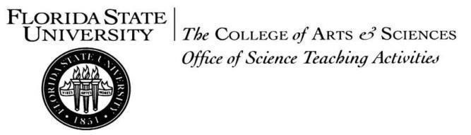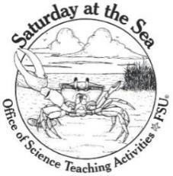
Dear Educator,
This summer Florida State University will be sponsoring Saturday-at-the-Sea Summer Day Camps (SATS Camp). This program introduces middle school students to experimental marine biology. These camps are funded by the Office of STEM Teaching Activities at Florida State University. Each camp will include up to 12 students with instructors and teachers. To be eligible, students must be Florida residents, able to swim and currently enrolled in 6th, 7th, or 8th grade.
As a science teacher, your role is very important to this program. Please nominate five of your students. We are not just looking for your best and brightest students, but also those who need encouragement to develop enthusiasm for science. We are looking for a diverse, inquisitive group of students who will benefit from SATS Camp. You are the best judge of this, so we appreciate your help!
You will need to fill out a student nomination form for each student. Additionally, each camp nominee needs a
Student/Parent Application that must be completed by the student nominee with their parents or guardians. These forms are due back to you by Monday 29 April 2024. Nominees are asked to write a brief essay explaining their reasons for wanting to attend SATS Camp. Final selection will be based on the information you, the student, and their family provide.
For a nomination to be considered, the entire application must be postmarked or emailed by Friday 3 May 2024 (please email wmturner@fsu.edu if you need more time). Our preference for application submission is email. If you mail the document, please follow up with an email so we can make sure we receive your application. Applications must be sent to one of the following:
SATS Camp
1062 King Life Sciences Bldg., FSU, 319 Stadium Drive Tallahassee, FL 32306-4295 email: wmturner@fsu.edu
If you have any questions, please contact us at wmturner@fsu.edu. If you need additional forms, please visit the website: https://www.bio.fsu.edu/osta/camp.php . Thank you very much for taking the time to help students find their way to our science camp!
Sincerely,
Bill Turner
Director of SATS Camps
1062 King Life Sciences Building
319 Stadium Drive
Tallahassee, FL
32306-4295
850-644-9828

Camp Goals: Saturday-at-the-Sea (SATS) Camp provides positive, science-related experiences to encourage Florida students to seek further scientific instruction and scientific careers. We also hope to raise their environmental awareness as they learn more about coastal marine habitats.
- DATES: June 3 – 7, June 10 – 14, July 8 – 12, July 22 – 26
- ELIGIBILITY:
▪ Be a current Florida resident
▪ Be currently enrolled in the 6th, 7th, or 8th grade and nominated by their current science teacher
▪ Be a strong swimmer
- COST: Free
- DEADLINE: The entire application must be postmarked by 3 May 2024
Camp Details: Campers will conduct investigations, learn about Florida Panhandle sea creatures, and explore coastal habitats. Campers will collect data, interpret their results, and present their findings to their peers, family, and friends on the last day of the camp. They will become marine scientists for the week!

STUDENT NOMINATION FORM
Saturday-at-the-Sea Summer Camp 2024

Name: ____________________________________________________________________ Age:_______
The student is currently in the ________ grade.
School: ____________________________________________________________________

Has this student ever attended the one-day Saturday-at-the-Sea (SATS) program? | Yes | No
Has this student ever participated in SATS Camp before? | Yes | No
Has the student participated in their school’s science fair? | Yes | No

Please assign a number to the student in the categories below. A score of 1 means the student has the least of the characteristic, 5 the most, and 3 in an average score for most students. Our goal is to have camps filled with compatible students who will work well together, and we will use these scores to help us select students.
 | 1 | 2 | 3 | 4 | 5 | Comments
Group Work
Interest in Science
Maturity
Scientific Curiosity
Critical Thinking
Diligence
Self-Control
Communication
Detail-Oriented
Observer
Scholarly
Outdoorsy
Disruptive
Gets Along with
Others

I would rank this student _____ out of the five students that I am nominating.
Is there anything that we should know to inform our decision about this student?

Science Teacher Nominator Information

Teacher’s Name: | ____________________________________________
Subject Taught: | ____________________________________________
School: | ____________________________________________
Work Phone: | ____________________________________________
Email: | ____________________________________________
How long have you known this student? ____________________________________________
Please describe how this student would benefit from the SATS Camp and provide information to help us decide whether this student is selected. Admission to this camp is competitive and your input here is extremely important for the evaluation process. Thank you for your time! Please include extra pages if necessary.
Email or mail this form with your Student Application filled out by the student and their parents or guardians postmarked by 3 May 2024.
Return this form to:
SATS Camp
1062 King Life Sciences Building
319 Stadium Drive
Tallahassee, FL 32306-4295
Fax: (850)-644-0643 Email: wmturner@fsu.edu

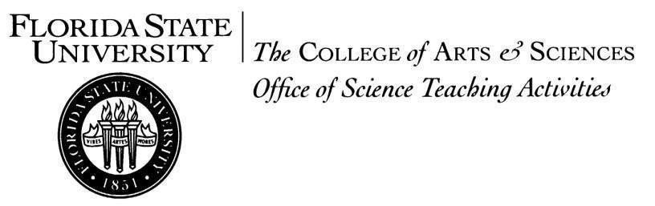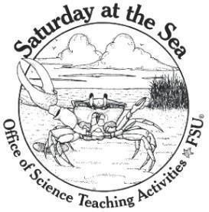
Dear Parent/Guardian of a Saturday-at-the-Sea Summer Camp Nominee:
Your child has been nominated by their science teacher to participate in the Saturday-at-the-Sea Summer Camp (SATS Camp). Our Camp teaches students about coastal ecosystems and stimulates their interest in marine biology. Our Camp is a fun and challenging introduction to this exciting field. These free, week-long day camps are funded by the Office of STEM Teaching Activities at Florida State University.
Campers will work as part of a student marine biology research team studying the Gulf Coast. During camp week, we will explore marine habitats and conduct scientific studies. On the last day of camp, the students will present their research to you, other parents, and to their peers. We will also require that you and your child attend a pre-camp orientation on Saturday, June 1, 2024 from 10:00 am - 12:00 pm.
To give your child the best chance at being selected to participate, please help them fill out the attached student application. Please make sure that all possible dates for participation are ranked on the application form so we can try to give you the dates that work best for you. Your child should write a 500-word essay detailing their reasons for attending SATS Camp. Return the completed application to your child's teacher as quickly as possible to ensure that the entire application packet can be returned to us on time. Students must return the student/parent portion of the application to their nominating teacher by Monday April 29, 2024.
You will be notified VIA EMAIL by Friday, May 17, 2024 if your child is chosen to participate. If accepted, you will receive more details regarding the camp. If you have any questions about SATS Camp, please visit our website https://www.bio.fsu.edu/osta/camp.php or email us at wmturner@fsu.edu. Hopefully, we will be meeting you and your child soon!
Sincerely,
Bill Turner
Director of SATS Camps
1062 King Life Sciences Building
319 Stadium Drive
Tallahassee, FL
32306-4295
850-644-9828

For Parent To Complete

Parent/Guardian Name: _______________________________________________________

Student Name: ______________________________________________________________

Daytime Phone: _____________________________________________________________

Best Contact Email: __________________________________________________________
***DO YOU CHECK YOUR EMAIL REGULARLY? (please circle answer) Yes No
Should my child be selected to participate in one of the Saturday-at-the-Sea Summer Camps (please initial):
_____ I am aware that I AND MY CHILD must attend an important pre-camp orientation on Saturday, June 1, 2024 from 10:00am-12:00pm.
_____ I understand that my child will attend every day of camp unless ill or with some other valid excuse.
_____ I understand that we will be notified of camp status VIA EMAIL by Friday, May 17, 2024. I will be checking my email regularly during this time.
Parent's signature: ___________________________________________ Date: ___________________
STUDENT APPLICATION
Saturday-at-the-Sea Summer Camp 2024
Student Name: ___________________________________________________________
Mailing Address: __________________________________________________________
Home Phone: ____________________________________________________________
Date of Birth: _____________________________________________________________
My Email: _______________________________________________________________
My Parent’s Email: ________________________________________________________
My School: ______________________________________________________________
I have attended SATS before. If so, when? _____________________________________
Do you know anyone who has attended SATS Camp before? If so, who?
_______________________________________________________________________
In fall 2024, I will be going into the ________grade.

Camp selection: (the more camps you check, the better your chance of getting in!)
Dates | I can attend this camp! | My preference rank
June 3 – 7
June 10 – 14
July 8 – 12
July 22 – 24

Should I be selected to participate in one of the Saturday-at-the-Sea Summer Camps (please initial):
_____I am aware that both my parent/guardian and I must attend an important pre-camp orientation on Saturday, June 1, 2024 from 10:00am-12:00pm.
_____ I can swim.
_____I am aware that I will be required to work hard at this camp, but I will also have fun!
_____I am aware that this camp is offered free of charge. I will make the most of my time there!
What do you like most about science?
________________________________________________________________________________________
________________________________________________________________________________________
________________________________________________________________________________________
________________________________________________________________________________________
What other summer camps have you attended in the last four years?
________________________________________________________________________________________
________________________________________________________________________________________
________________________________________________________________________________________
________________________________________________________________________________________
In the space below, please describe why you would like to participate in the Saturday-at-the-Sea Camp.

