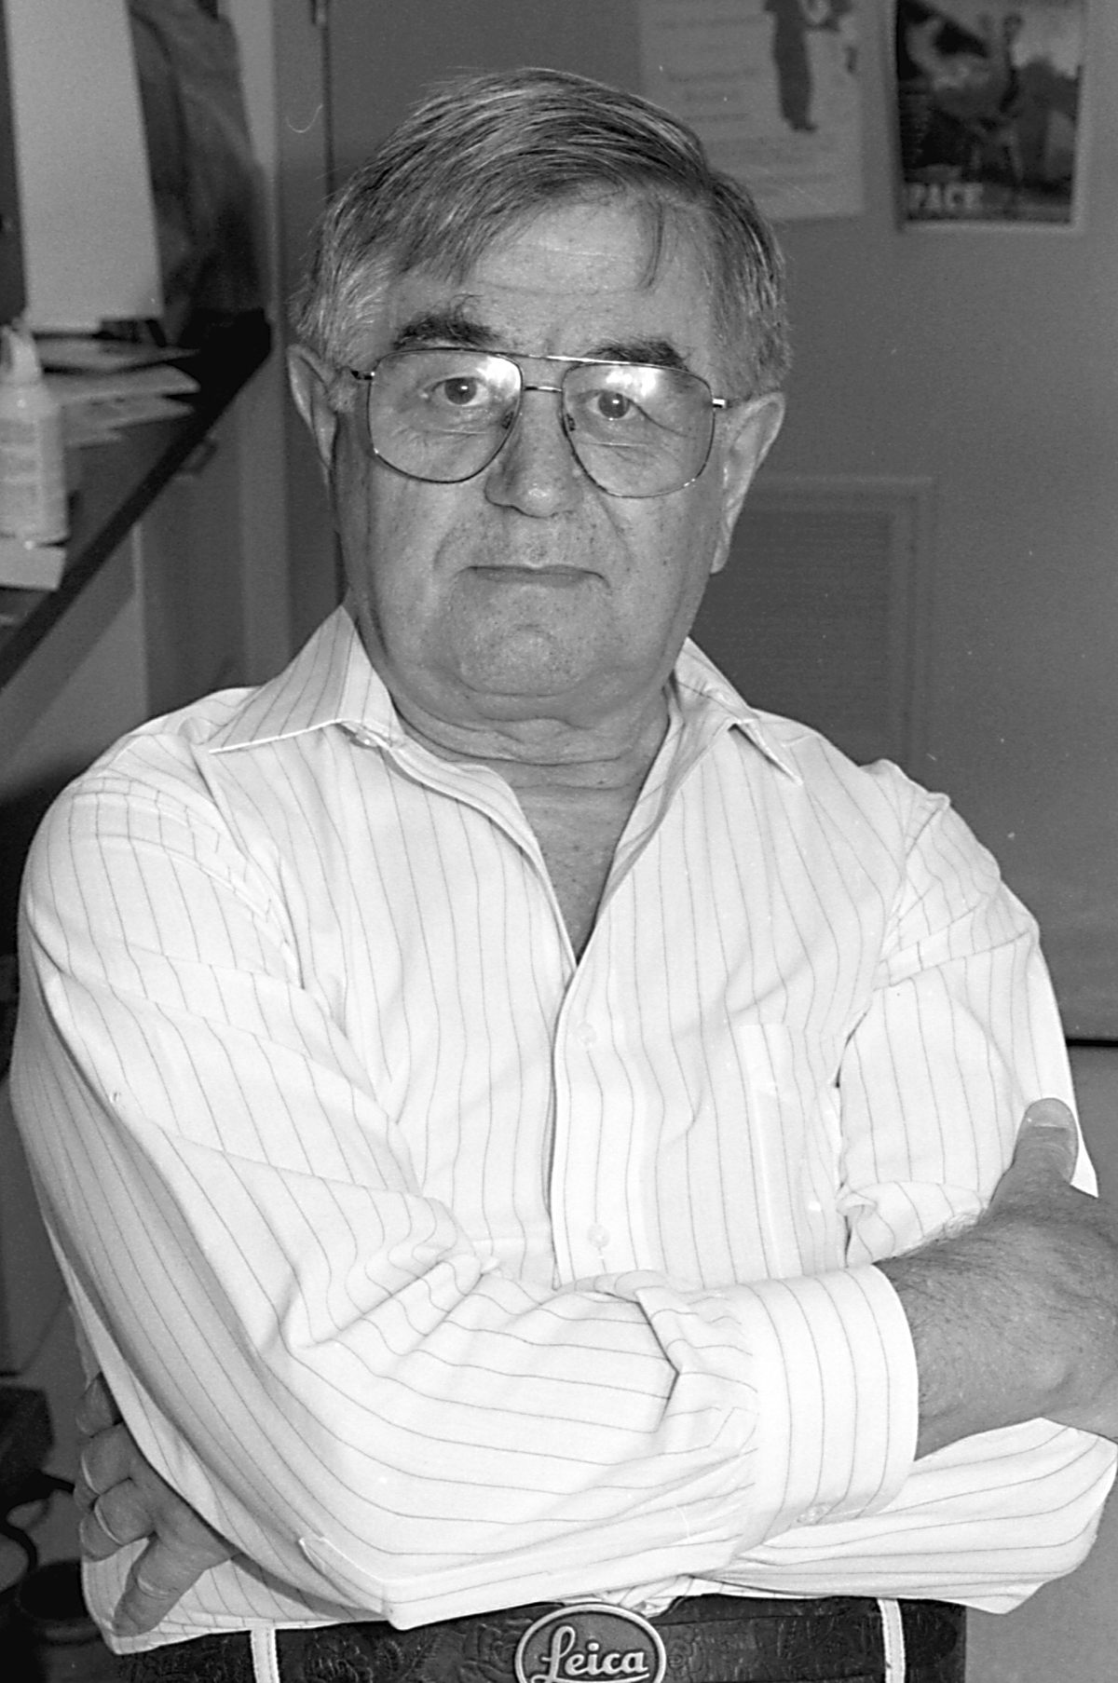

PASQUALE P.C. GRAZIADEI 1921 – 2002

Pasquale Graziadei, a pioneer in olfactory-system research and author of more than 60 research papers and hundreds of abstracts died June 2nd 2002 in Tallahassee FL, USA, where he was Professor Emeritus of Biological Science and Neuroscience at Florida State University. Pasquale Graziadei was a founding member of the Association for Chemoreception Sciences (AChemS) and a well known contributor to symposia and conferences on olfactory anatomy and development through the ‘70s, 80’s and early 90’s. A well loved character and valuable collaborator for many within the field, he could be uncompromising, insightful and funny all at the same time. Pasquale’s “stories” were always entertaining and perceptive, his criticism constructive and at times pungent, his passing is the end of an era. He retired from Florida State University in 1996.

Pasquale Graziadei was born in Pavia, Italy, in 1921 and studied medicine at University of Pavia, graduating with an MD in 1947. He joined the Department of Anatomy Pavia, the institution of legendary anatomists Antonio Scarpa and Camillo Golgi, as the equivalent of Assistant Professor, and studied with a student of Golgi’s. In 1952 he took a position as Associate Professor of Anatomy at the University of Genoa, becoming the equivalent of Full Professor in 1958. He spent summers at the “Stazione Zoologica” at Naples, meeting there J.Z. Young and others of the nascent international neuroscience community. In 1962 he moved to London at the invitation of Young and others to continue his anatomical research at University College. While there, he met Lloyd Beidler who invited him to Florida State University where he did the bulk of his work - and acquired an international reputation as an outstanding research scientist and innovator. In 1982 he was awarded the first IFF-Stanley K Freeman award (through AChemS) for outstanding contributions to chemoreception research. In the same year he was awarded the Allessandro Volta Award from his alma mater, the University of Pavia. In 1987, he was honored by the “Instituto Neurologico C. Besta” for contributions to scientific discovery and, in that year also, received a prestigious Jacob Javits 7-year research-funding award. In 1993 Pasquale Graziadei was appointed Distinguished Research Professor at Florida State University. He was a regular ad-hoc panelist for many NIH and NSF site visits, a managing editor for Journal of Applied Histochemistry, associate editor for Journal of Neurocytology, and a contributor to the National Strategic Reseach Plan that lead to the creation of the National Institute of Deafness and other Communication Disorders. Graziadei was the first to suggest, and then to demonstrate that olfactory receptor neurons were continually generated in vivo and that the population of globose basal cells serves as progenitors for the newly born neurons. He showed that olfactory neuron axons were critical in inducing the formation of their normal target, the olfactory bulb, during normal development. Using embryonic transplants, he showed that these axons could even invade and form synapse-like structures with CNS neurons in a wide range of other brain structures. In these studies Pasquale Graziadei’s collaborators included his wife Ariella Monti-Graziadei, who made critical contributions to many studies, in addition to a series of graduate students and postdocs at Florida State University.

Michael Meredith and Edward E. Morrison

